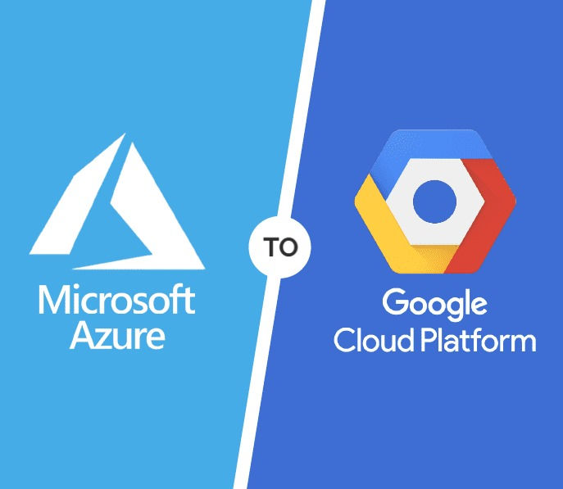

**APPLICATION MIGRATION IN PUBLIC CLOUD**

**OBJECTIVE**

The primary objective of this project is to successfully migrate the organization’s applications, databases, and associated resources from Microsoft Azure to Google Cloud Platform (GCP) to achieve better alignment with the organization’s evolving technical and business needs.

**Specific objectives include:**

* **Cost Efficiency**: This migration aims to reduce operational costs in the current Azure environment. GCP’s competitive pricing, sustained use discounts, and resource optimization opportunities are expected to deliver significant cost savings.
* **Enhanced Performance**: The goal is to boost application performance by leveraging GCP’s scalable infrastructure. Services like Google Compute Engine and Kubernetes Engine will enhance speed, reliability, and scalability, supporting the organization's digital transformation.
* **Access to Advanced Tools**: The project seeks to empower the organization with GCP’s advanced data analytics, machine learning, and AI tools, such as BigQuery and TensorFlow, to drive innovation and enable smarter, data-driven applications.
* **Security and Compliance**: Maintaining or improving security and compliance is crucial. The migration will utilize GCP’s robust security features and compliance certifications to uphold the organization's security standards.
* **Minimal Disruption**: The migration will focus on minimizing downtime and disruption to business operations, ensuring a smooth transition that maintains continuity and safeguards data integrity.

**INTRODUCTION**

Cloud migration is the process of transferring applications, data, and other business elements from an on-premises data centre or one cloud environment to another, such as a public, private, or hybrid cloud. The primary goal of this migration is to take advantage of the benefits that cloud platforms offer, including scalability, cost efficiency, and enhanced flexibility. Businesses may choose to migrate to the cloud in different ways, depending on their specific needs and goals.

This project focuses on migrating an organization's applications and resources from Microsoft Azure to Google Cloud Platform (GCP). The decision to migrate is driven by challenges such as rising costs, suboptimal performance, and limited access to advanced tools in the current Azure environment, which no longer fully aligns with the organization's evolving technical needs and business goals. In contrast, GCP offers a suite of services that better address these challenges, particularly in data analytics, machine learning, and cost management. The scope of this migration project includes a comprehensive transfer of the organization's applications, databases, and resources from Azure to GCP. This process involves thoroughly assessing the existing environment, inventorying resources, mapping dependencies, and identifying potential risks. The chosen migration strategy—whether lift-and-shift, re-platforming, or refactoring—will ensure a smooth transition and optimization of applications for the new GCP environment.

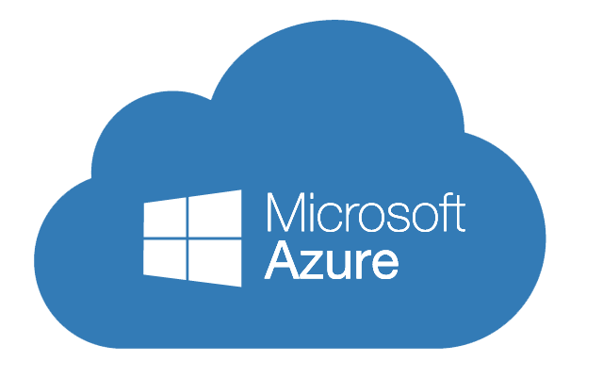**MICROSOFT AZURE**

The Azure cloud platform is more than 200 products and cloud services designed to help you bring new solutions to life to solve today’s challenges and create the future. Build, run, and manage applications across multiple clouds, on-premises, and at the edge, with the tools and frameworks of your choice. The Azure platform aims to help businesses manage challenges and meet their organizational goals. It offers tools that support all industries -- including e-commerce, finance and a variety of Fortune 500 companies -- and is compatible with open-source technologies. This gives users the flexibility to use their preferred tools and technologies. In addition, Azure offers four different forms of cloud computing: infrastructure as a service (IaaS), platform as a service (PaaS), software as a service (SaaS) and serverless functions.

|  |  |  |  |
| --- | --- | --- | --- |
| Azure Virtual Machines (VMs) | Azure Active Directory (AD) | Azure DevOps | Azure Virtual Network (VNet) |
| Azure Key Vault | Azure Site Recovery | Azure Blob Storage | Load Balancers |

**Some of the services provided by Azure are-**

**Some advantages of Azure are-**

* **Broad Integration**: Seamless integration with Microsoft products like Office 365 and Dynamics 365.
* **Enterprise Support**: Strong support for large-scale enterprise needs and hybrid environments.
* **Comprehensive Security**: Advanced security features and compliance with numerous standards.
* **Hybrid Capabilities**: Robust hybrid cloud options with Azure Arc and Azure Stack
* **Developer Ecosystem**: Rich set of tools for developers, including Visual Studio integration and Azure DevOps.

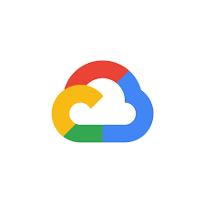**GOOGLE CLOUD PLATFORM**

Google Cloud Platform is a set of cloud computing services that Google offers, which runs on the same infrastructure that Google uses for its end-user products, such as YouTube, Gmail, and more. Google Cloud Platform offers a variety of services, including-Compute, Network, Machine learning and AI, Big data processing. Google Cloud Platform (GCP) provides cloud services through a global network of data centres. It offers scalable infrastructure resources, such as virtual machines and storage, with Compute Engine and Cloud Storage. For application development, GCP includes platforms like App Engine and Kubernetes Engine, which handle deployment and management. Serverless options like Cloud Functions enable code execution in response to events without server management.

|  |  |  |  |
| --- | --- | --- | --- |
| Compute Engine | Cloud SQL | App Engine | Cloud AI Platform |
| Kubernetes Engine | Cloud Storage | Cloud Pub/Sub | Cloud Run |

**Some of the services provided by Google Cloud Platform (GCP) are-**

**Some advantages of (GCP) are-**

* **Advanced Data Analytics**: High-performance tools like BigQuery for real-time and large-scale data analysis.
* **Strong AI and Machine Learning**: Integrated AI and ML tools, including TensorFlow and AutoML, for building intelligent applications.
* **Global Network Infrastructure**: Extensive global network providing low latency and high-speed connectivity.
* **Customizable VM’s**: Ability to create custom virtual machine types tailored to specific needs.
* **Open-Source Support**: Strong support for open-source technologies, including Kubernetes and other container tools.

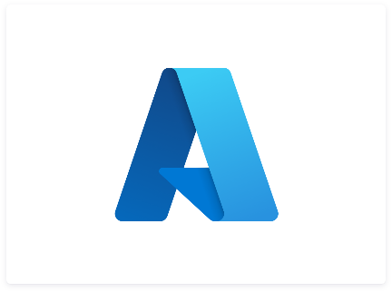**REASONS TO MIGRATE FROM AZURE TO GOOGLE CLOUD PLATFORM (GCP)**

* **Cost Savings**: GCP’s competitive pricing models, sustained use discounts, and cost management tools can lead to significant savings compared to Azure.
* **Superior Data Analytics**: GCP’s BigQuery offers faster and more efficient data analytics capabilities, ideal for handling large-scale and real-time data processing.
* **Advanced AI and Machine Learning**: GCP provides cutting-edge AI and machine learning tools, such as TensorFlow and AutoML, which may offer enhanced features and ease of use compared to Azure's offerings.
* **Global Network Performance**: GCP leverages Google's extensive global network infrastructure, providing low-latency and high-speed connectivity that can improve performance.
* **Custom VM Options**: GCP allows for highly customizable virtual machine types, giving more precise control over resource allocation and cost.
* **Integrated Tools:** GCP offers a suite of integrated tools for data processing, machine learning, and application development, which can simplify workflows and improve efficiency.
* **Innovative Technology**: GCP often leads in deploying innovative technologies and advancements, providing early access to the latest cloud computing trends and solutions.
* **Multiple outages reported recently in Ms azure public cloud that impacted a lot of customers across multiple geographies**: as a direct impact business hosting their mission critical apps and workloads in Ms azure got impacted and suffered financially.

**MIGRATION PROCESS**

Migrate to Virtual Machines provides a simple path for you to migrate your VMs to Compute Engine. The migration process occurs in the following distinct phases:

* **Onboard**: Select a source VM that you want to migrate.
* **Replication**: Replicate data from the source VM to Google Cloud. Data replication is a continuous process that takes place in the background until the final cut-over or you delete the migration.
* **Set VM target details**: Configure Compute Engine settings for the migrated VM, such as the project, instance type, memory, network, and more.
* **Test-clone**: Optionally create a Compute Engine clone of the source VM from the replication data and test it on Google Cloud.
* **Cut-over**: Migrate the source VM to Compute Engine. This process includes stopping the source VM, completing a final replication, and creating the production Compute Engine instance from the source VM.
* **Finalize**: Perform any final cleanup after a successful migration.
* The following image shows these phases:

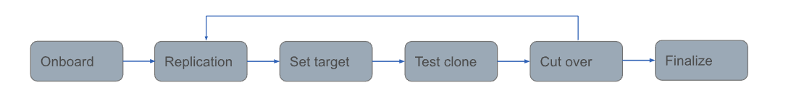

**KEY STEPS IN THE MIGRATION PROCESS**

1. **LET'S SET UP THE GOOGLE CLOUD PLATFORM FREE TRIAL ACCOUNT.**
   1. ****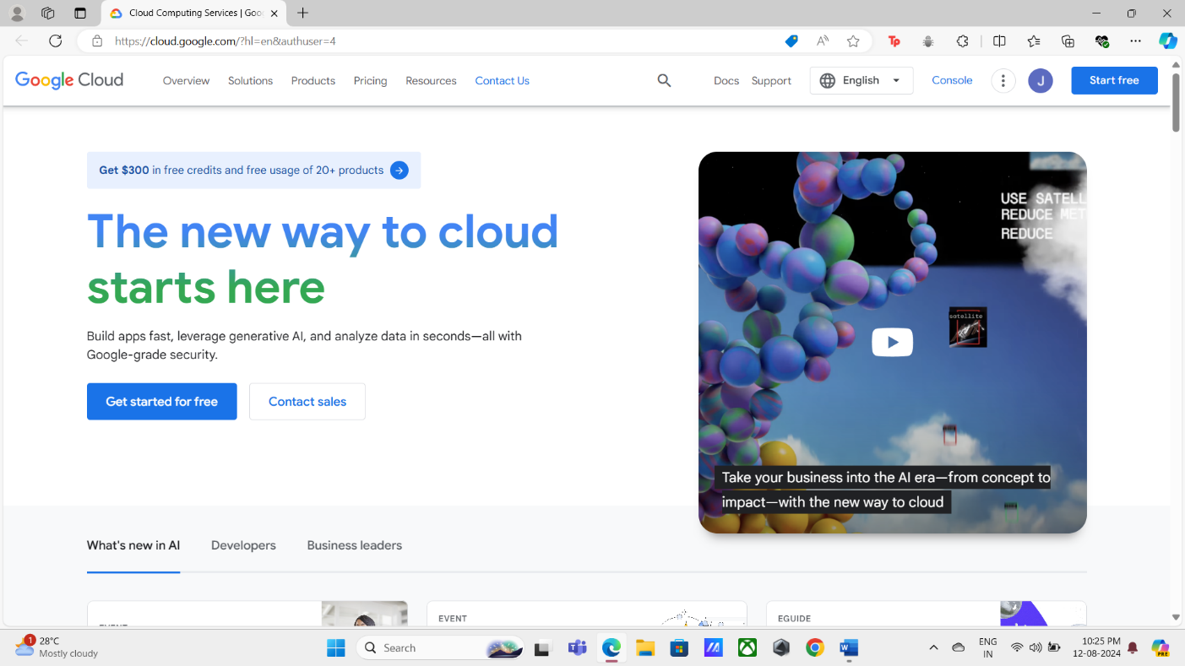Type [google.cloud.com](https://cloud.google.com/?hl=en&authuser=4) in the browser.

* ****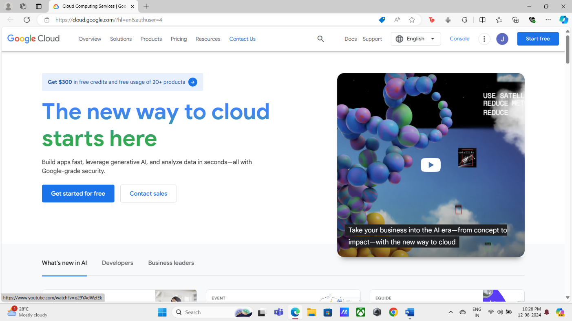Click on start free.
* ****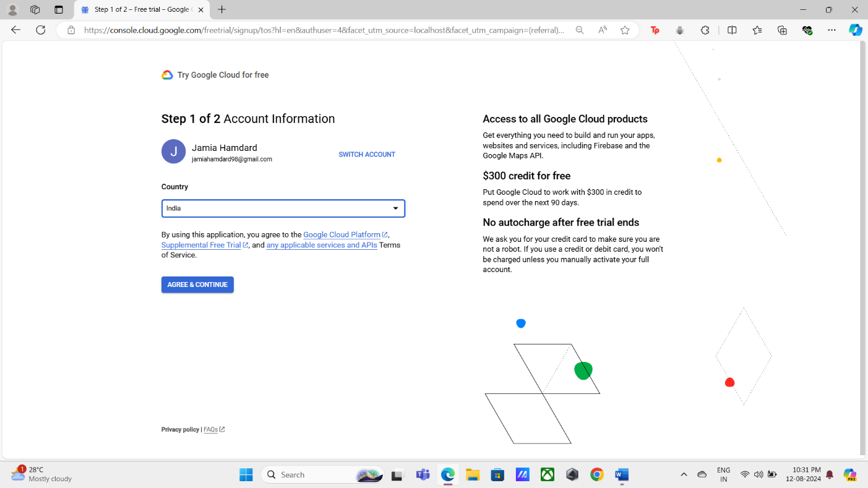Choose your country and click on agree and continue.
* 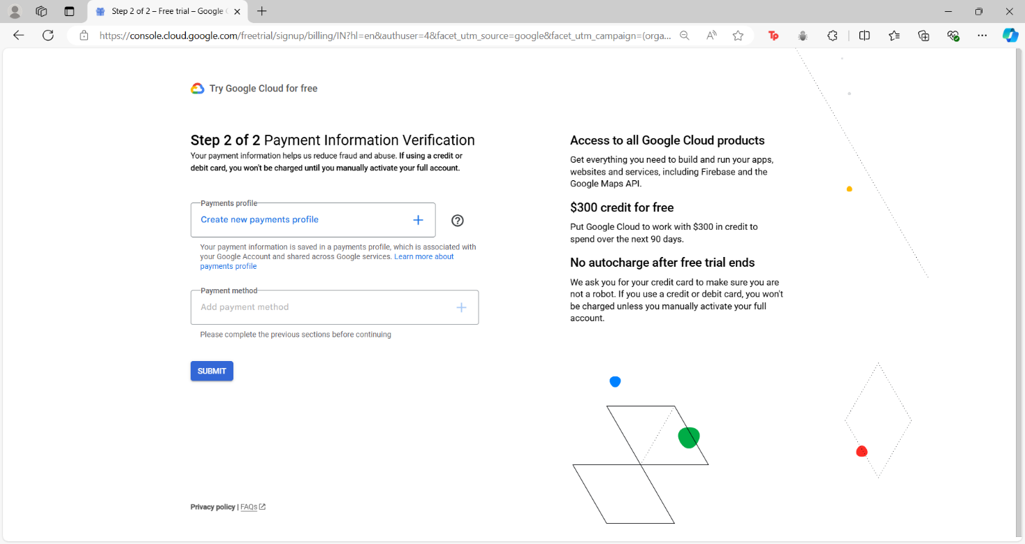Create your payment profile and provide all the necessary information.
* 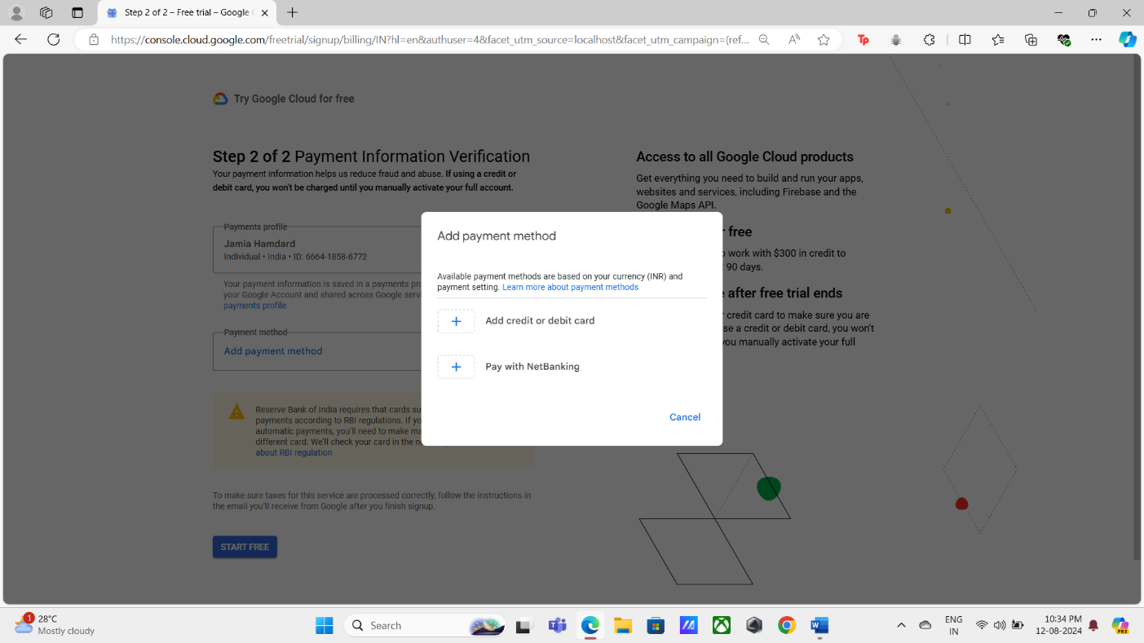Add a payment method and click on Start free.

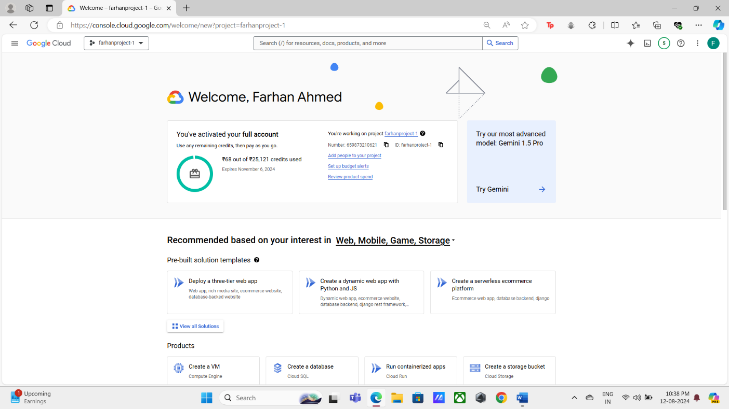(After clicking on start free ₹2 will be deducted from your account for the confirmation process.)

* You are now set to go, having been given $300 USD to use on the platform for 90 days and free access to all required Google Cloud services.
  1. Install the google cloud CLI.
* Install the gcloud CLI- <https://cloud.google.com/sdk/docs/install-sdk>.
* Select the Architecture of your machines (Linux, Debian/Ubuntu, Red Hat/Fedora/CentOS, macOS, Windows, Chromebook).
* 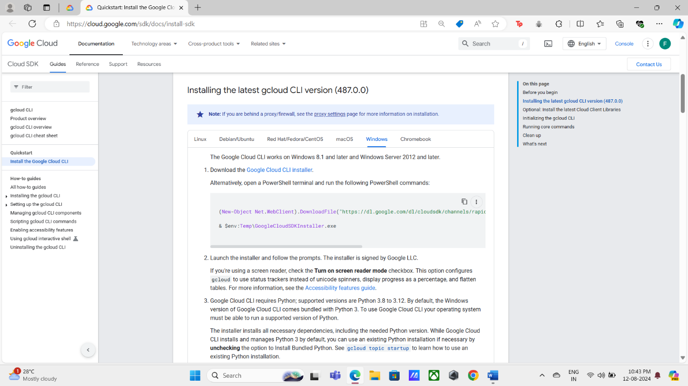Click on download the Google Cloud CLI installer.
  1. Set up the Google cloud CLI.

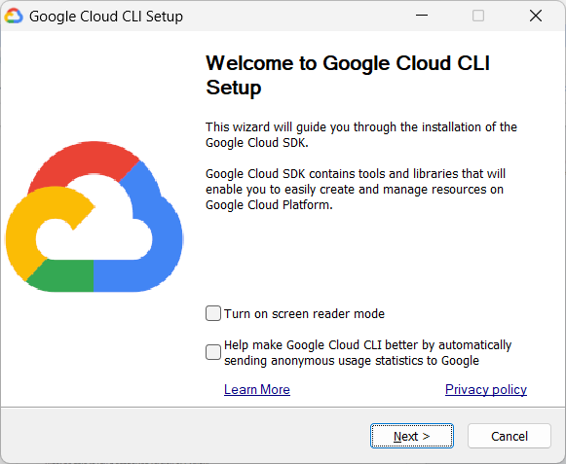

* Click on next.
* 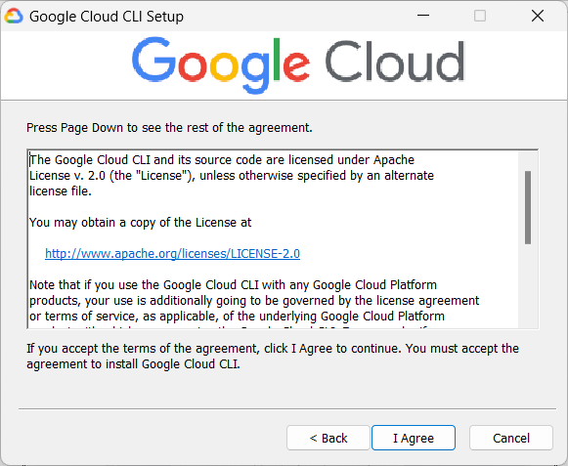Click on I Agree after reading the agreement.
* Select the install type and click on Next.

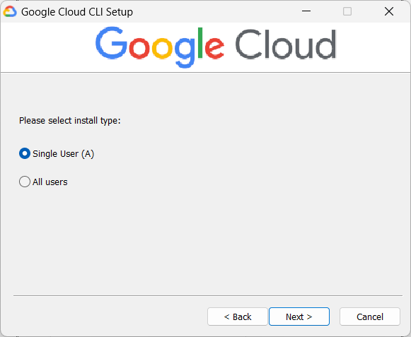

* 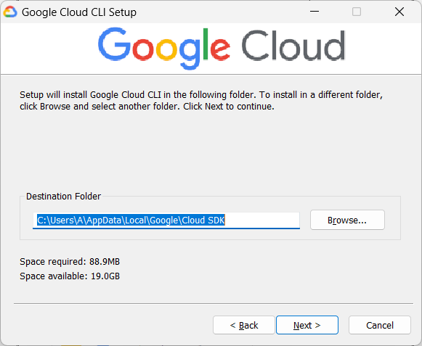Select the Destination folder and click on Next.
* 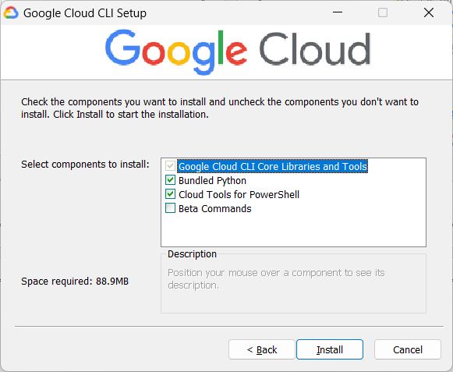Check the components you want to install and Click on Install to start the installation.

(The gcloud CLI will now function after the installation is finished.)

* 1. Open command prompt(cmd).
* 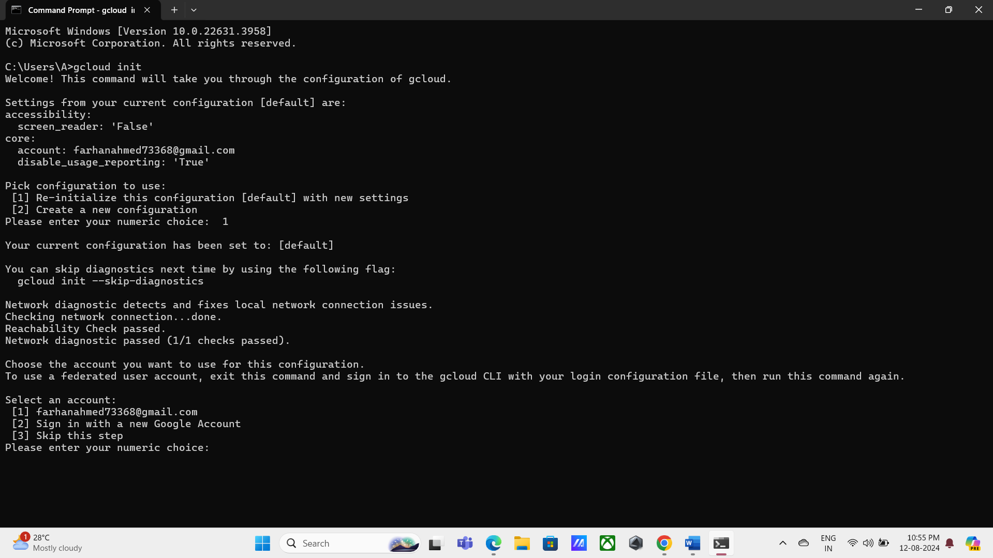Write gcloud init.

(In order to access Google Cloud SDK, you will be prompted to sign in.)

* 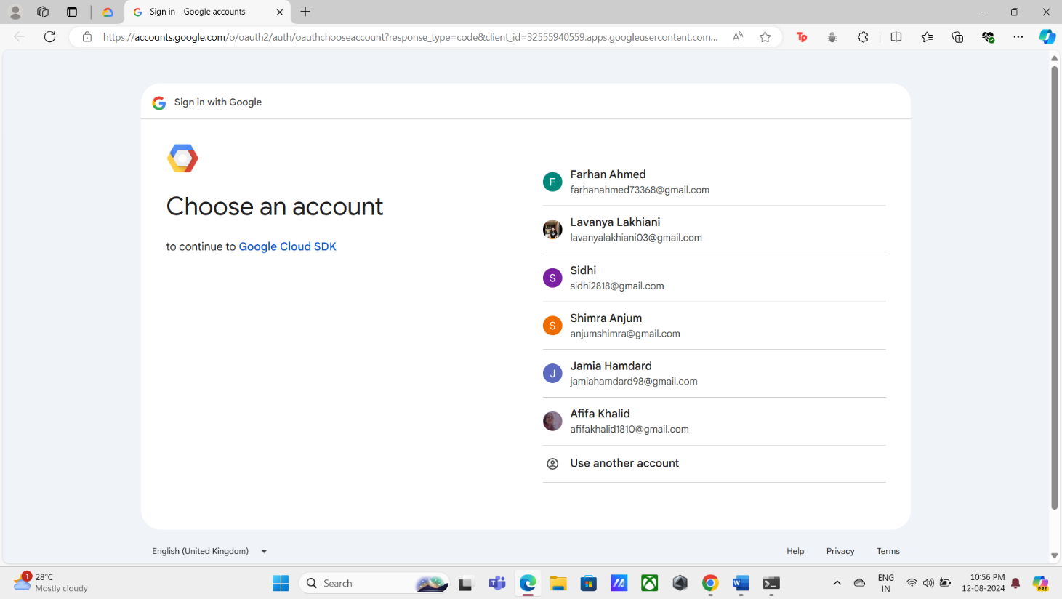Select the account you wish to use to log in.



* 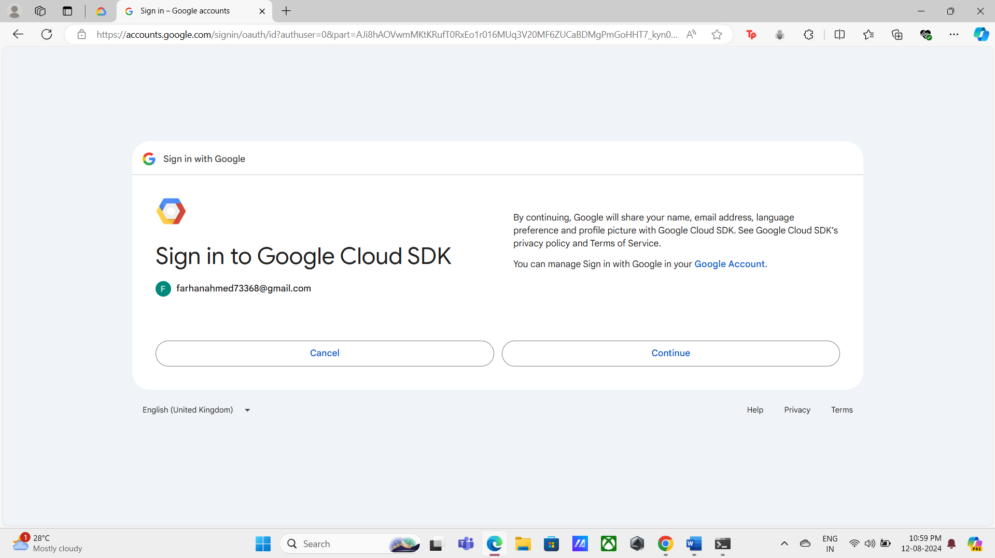Click on Continue.
* 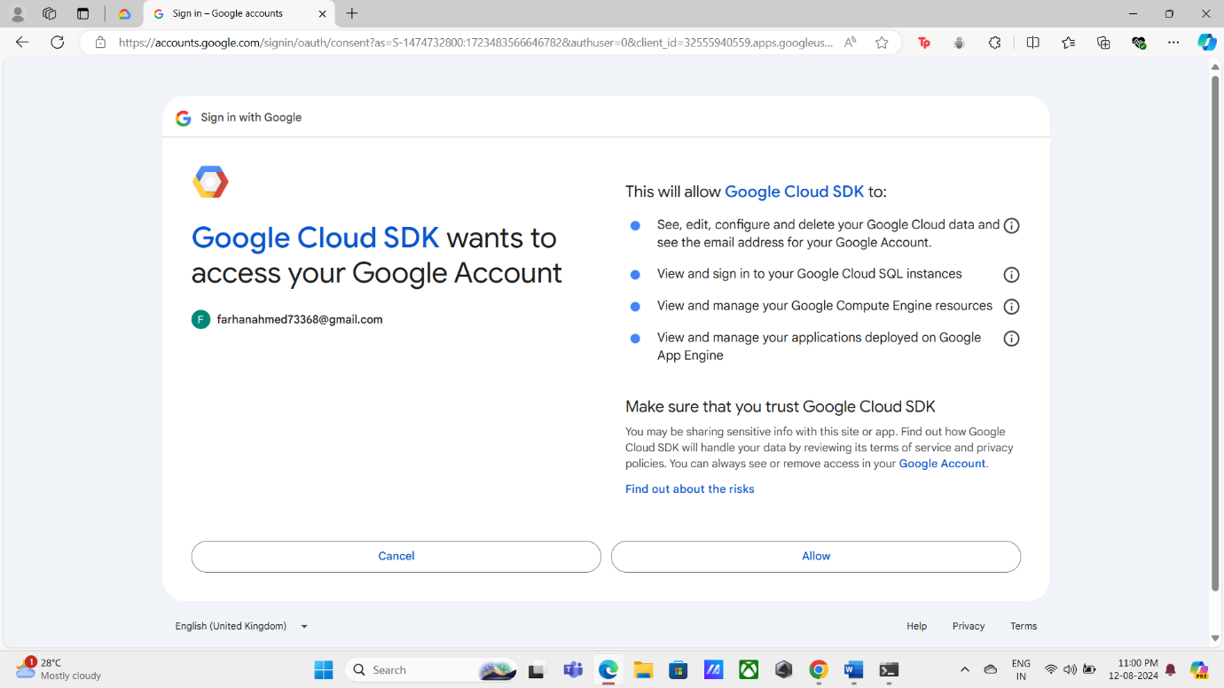Click on allow.
* 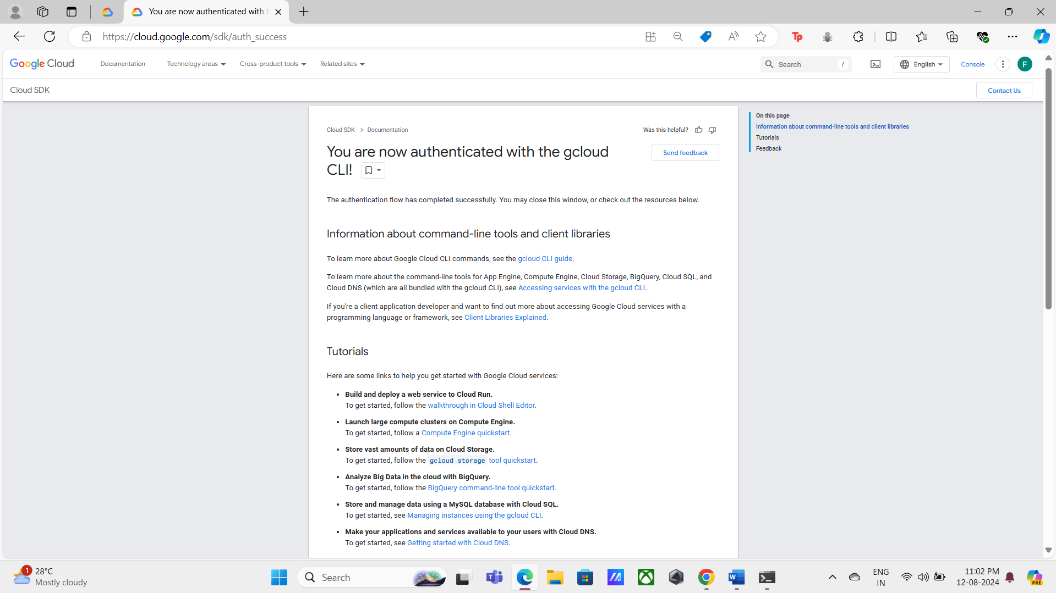Your gcloud CLI authentication will be successfully completed.
* 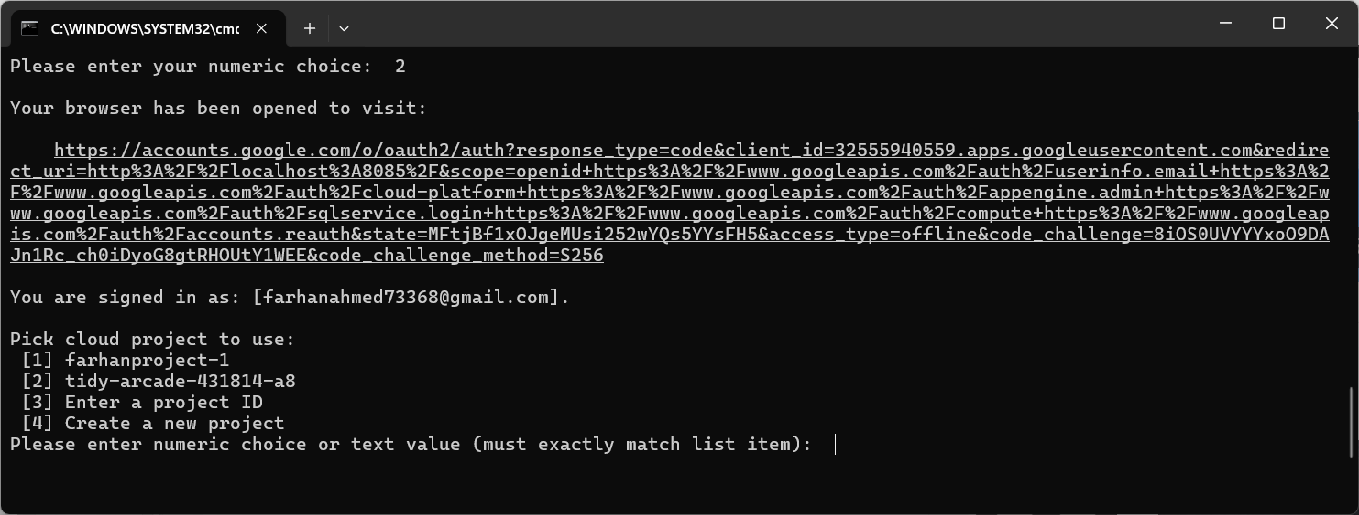After indicating that you are logged in with the selected ID, the command prompt will ask you to select an existing project or create a new one.
* 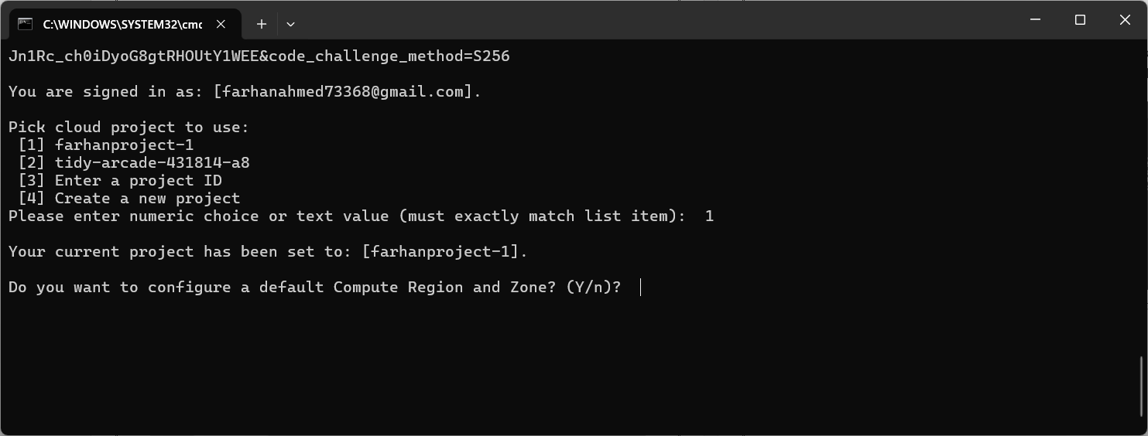You will be prompted to configure a default compute region and zone after selecting the cloud project. You can choose to respond with a yes or no.
* 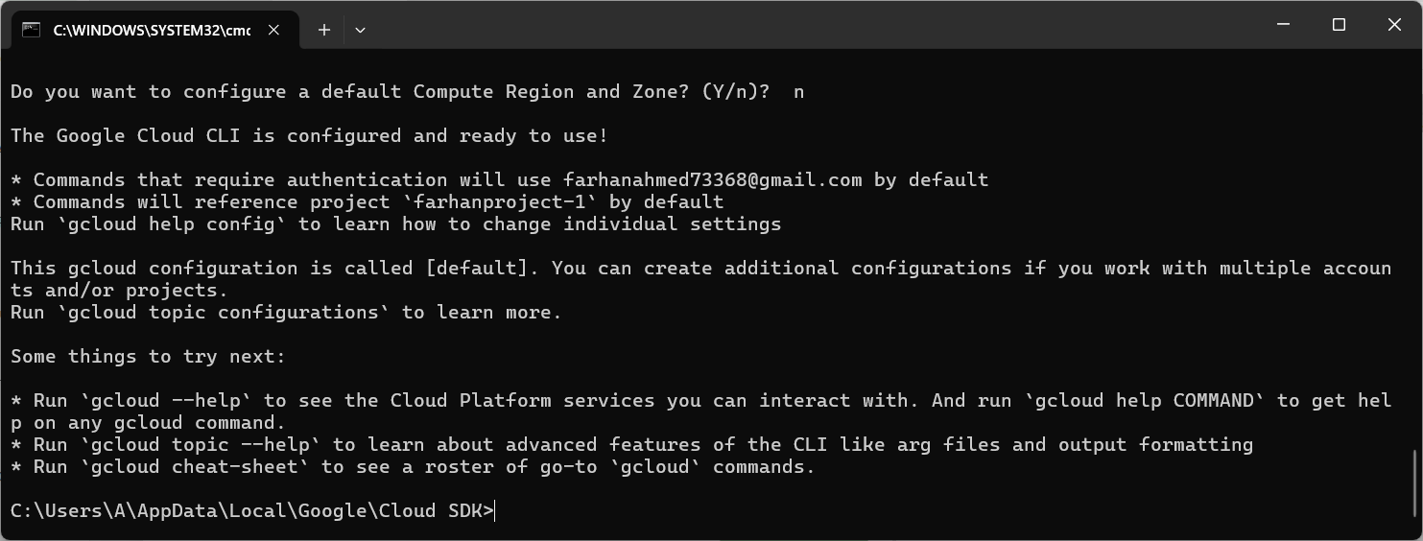**The gcloud CLI has been configured and is now operational.**

1. **CREATING AN AZURE SOURCE.** 
   1. 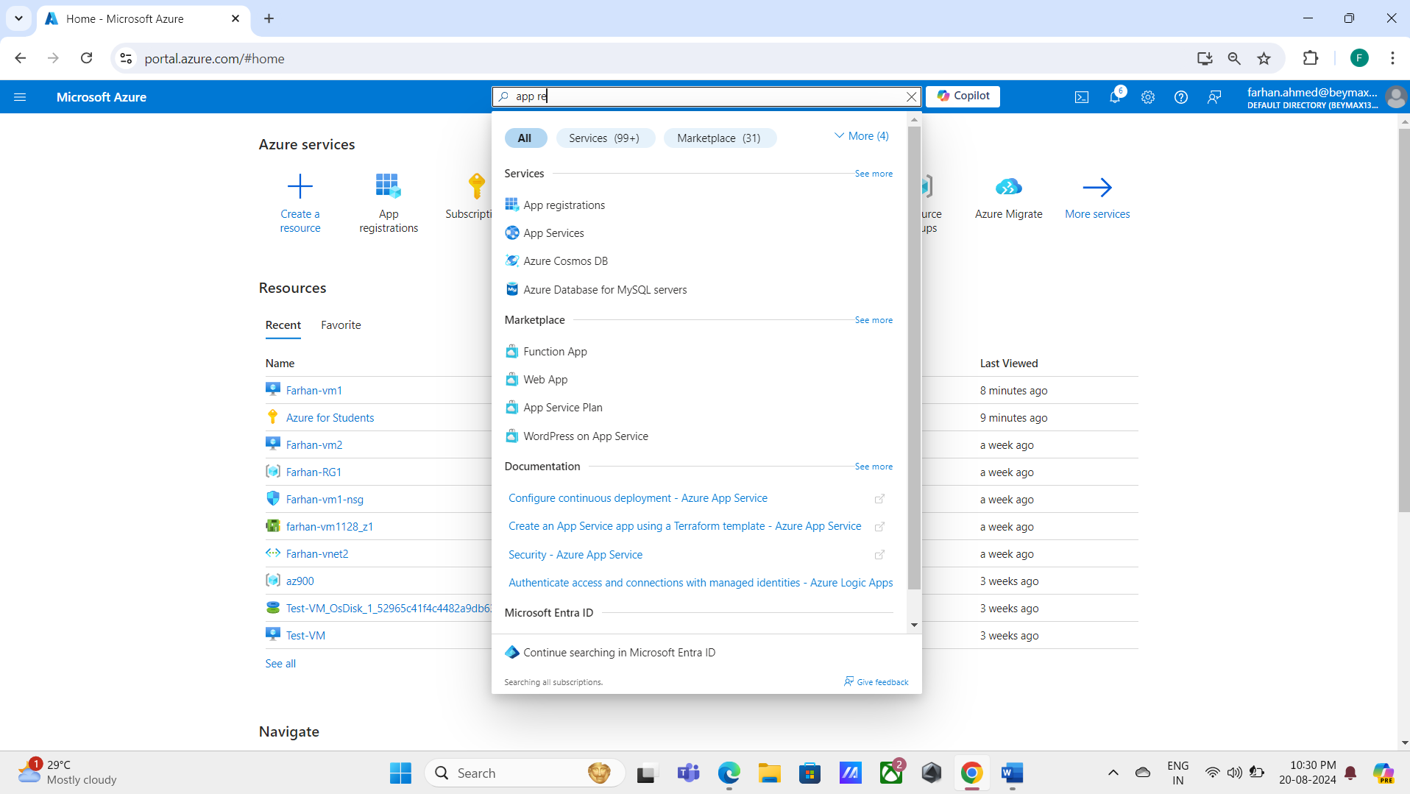In Azure, we will first register an app in App Registration.

* 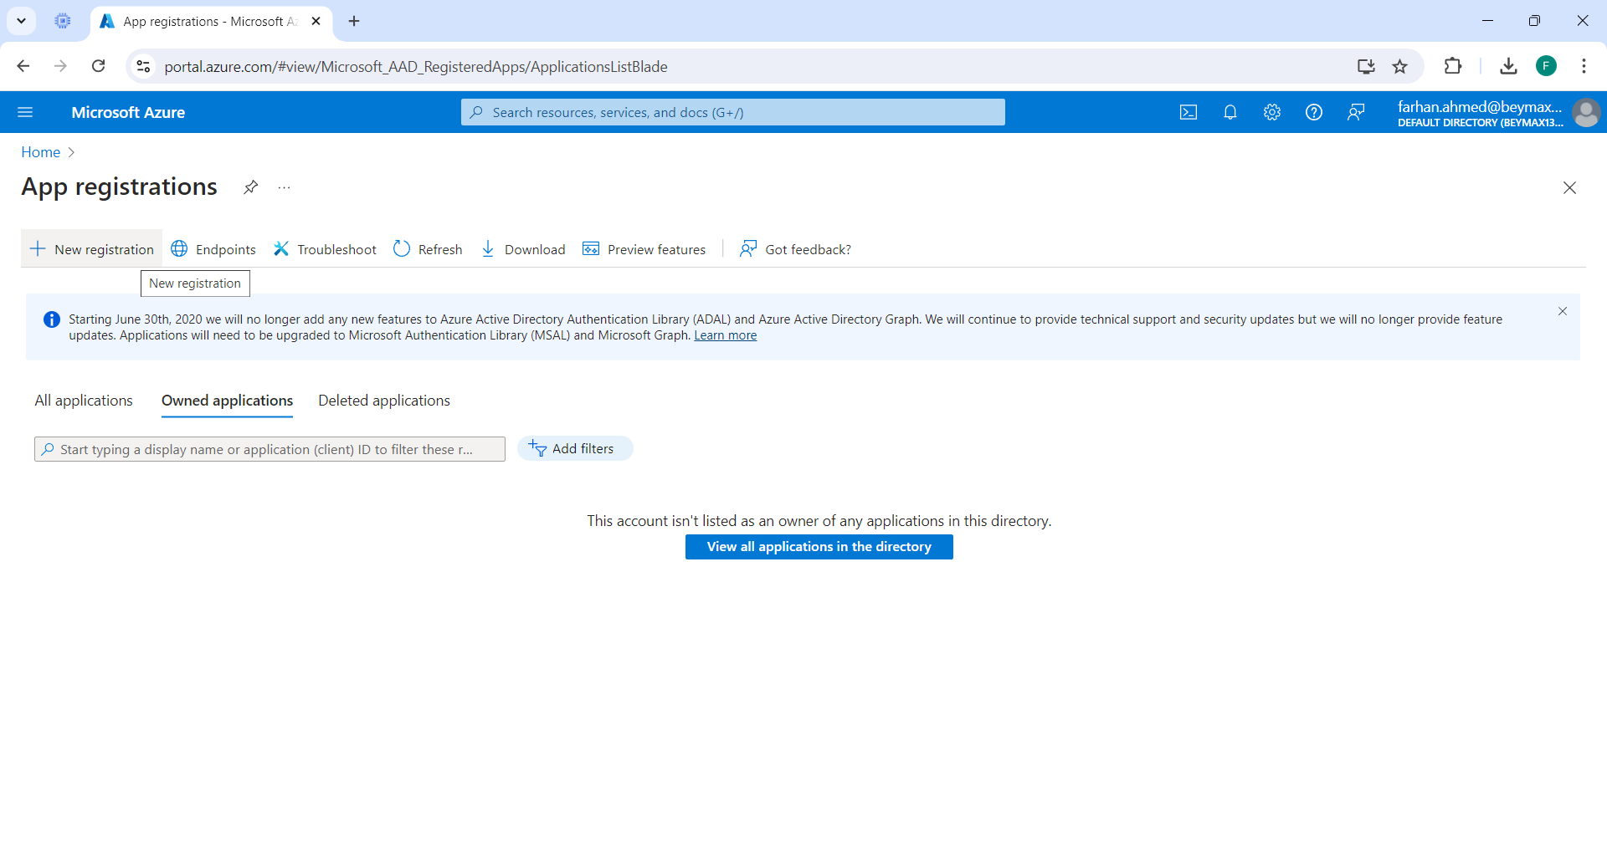Click on New Registrations.
* 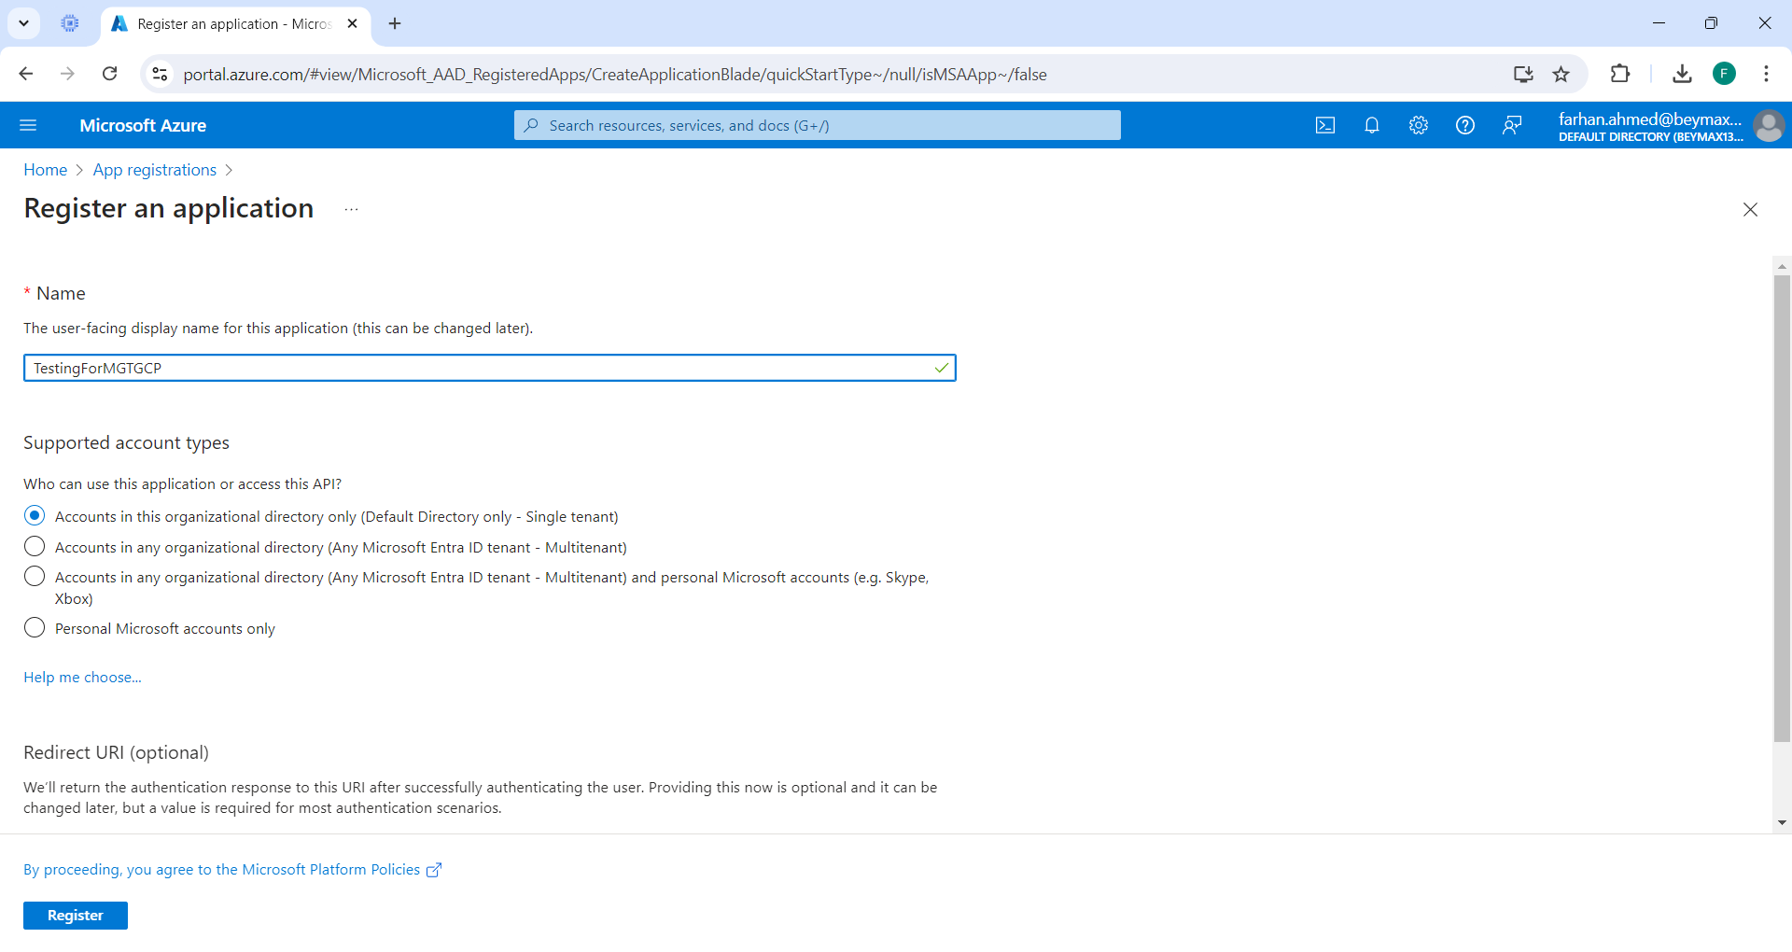Enter the app's name and the supported account types, and finally click Register.
* Your app will be successfully registered.

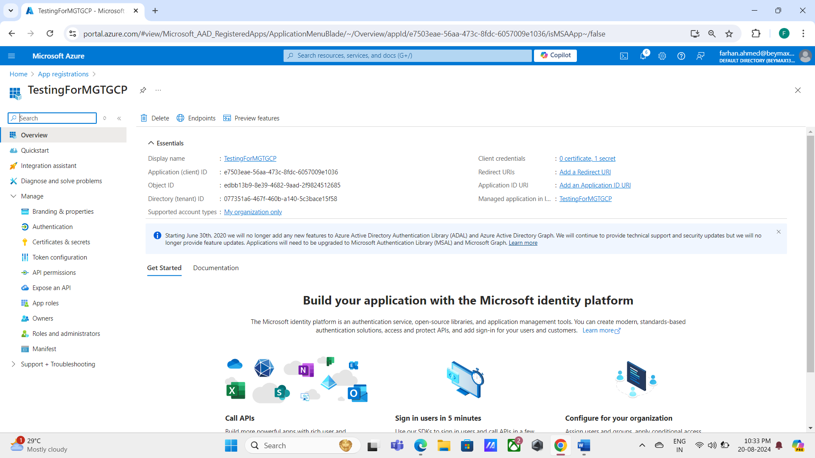

* 1. 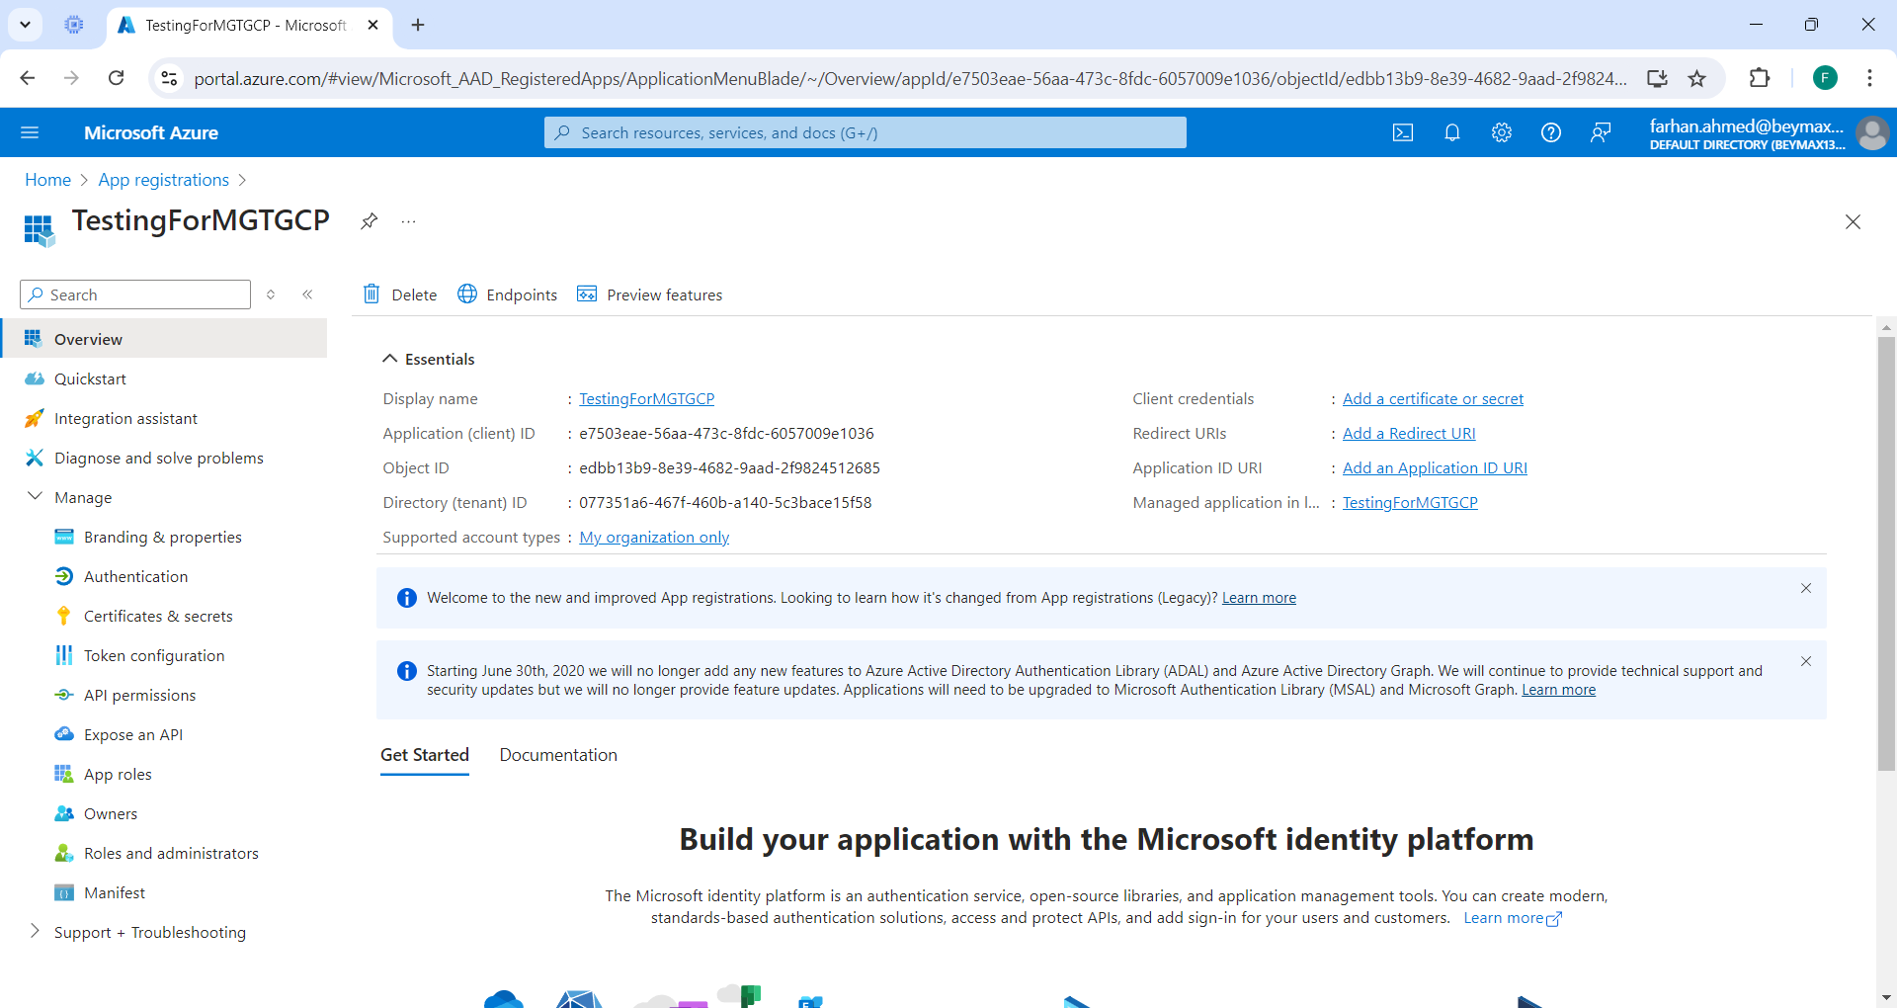Click the "Certificates & secrets" option.
* 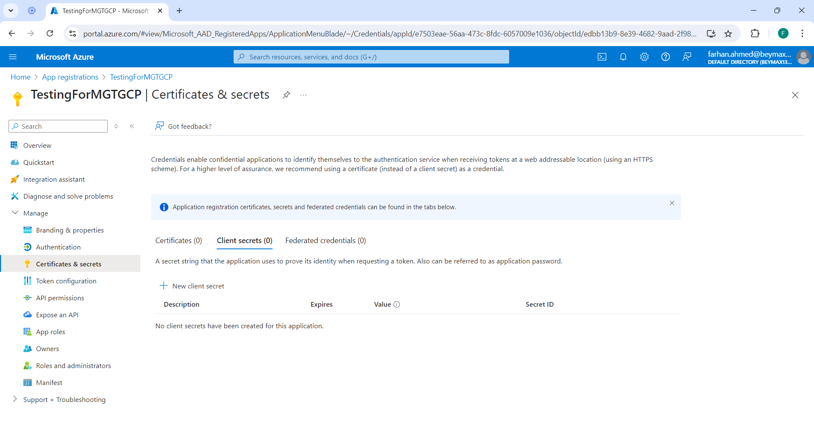Click on New client secret.
* 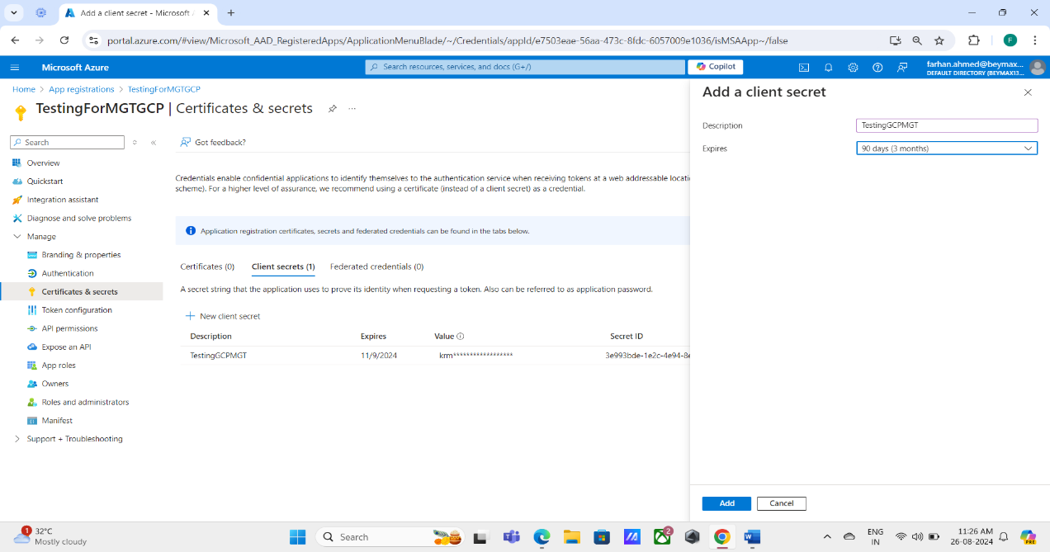Add a client secret by providing a description and choosing the expiration time and click on Add.
* 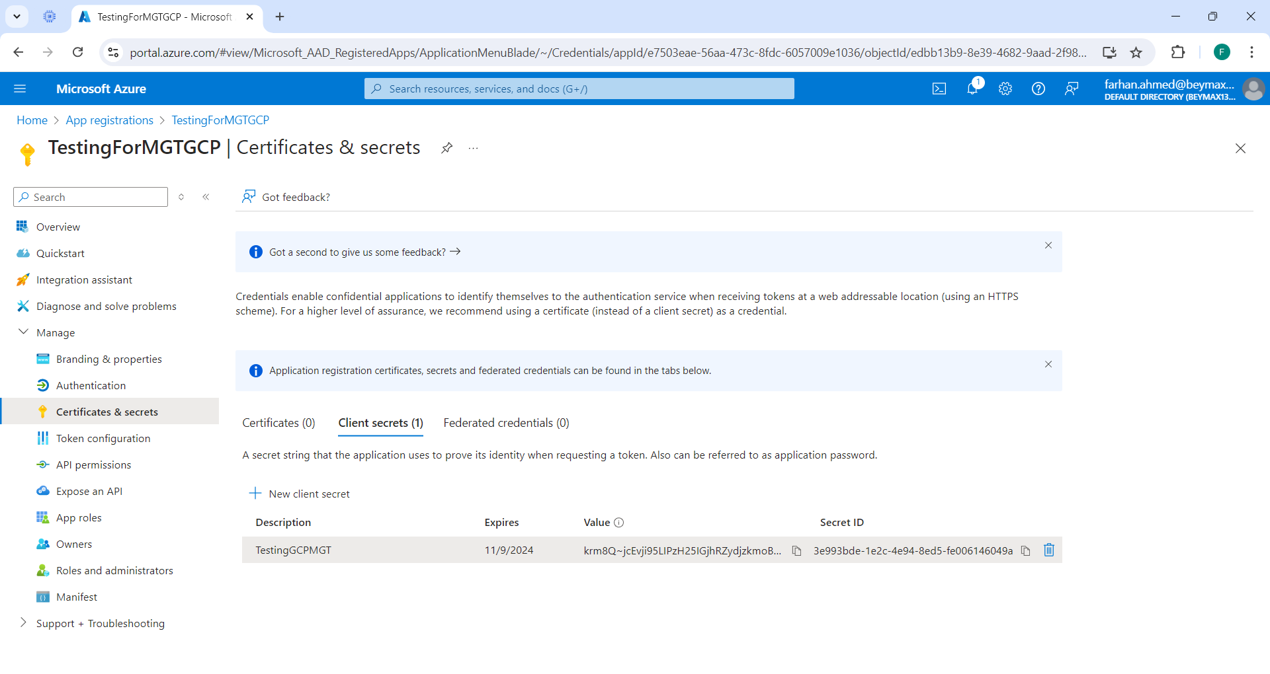Make a copy of the "value" credential because it is only available once and disappears as soon as we switch to a different service because it is equivalent to a password.
  1. 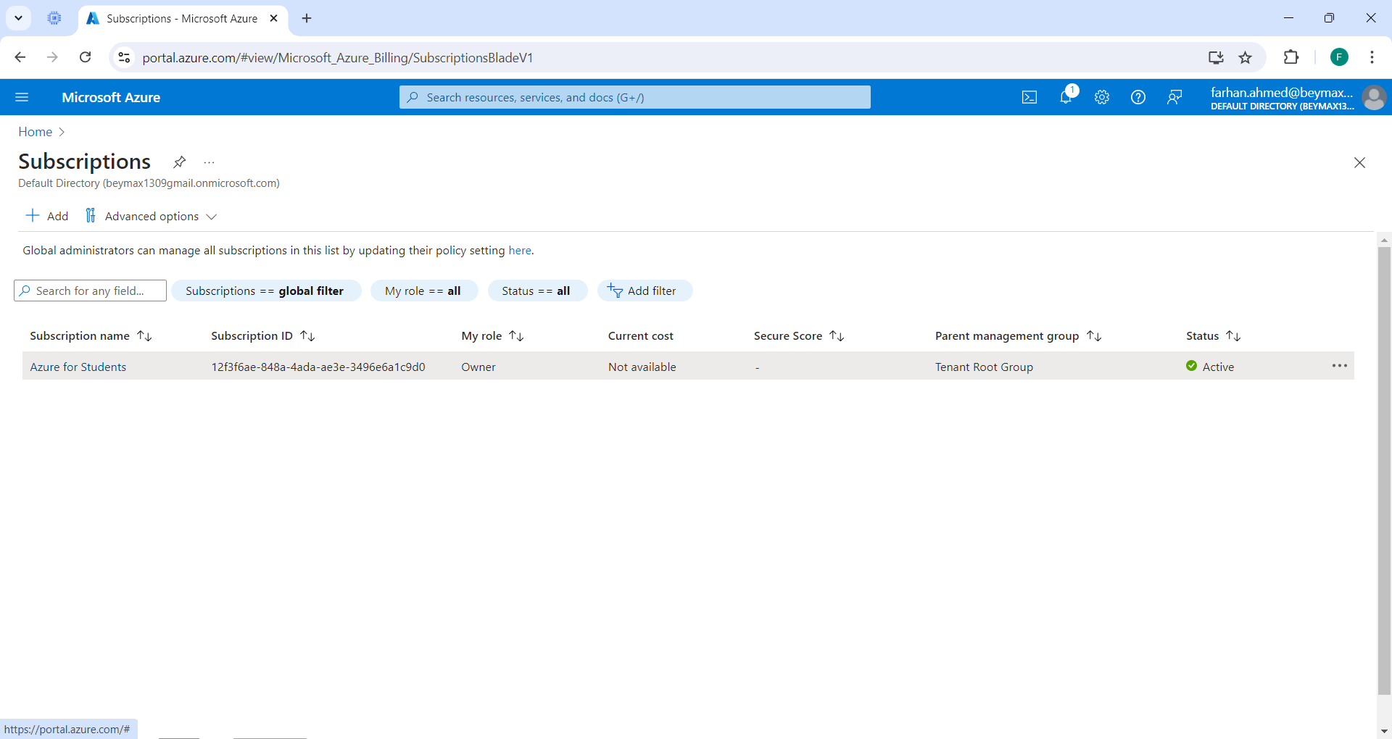We will now move to the subscriptions tab in order to give the Google Cloud Migration Service on your source environment the minimal set of privileges.
* 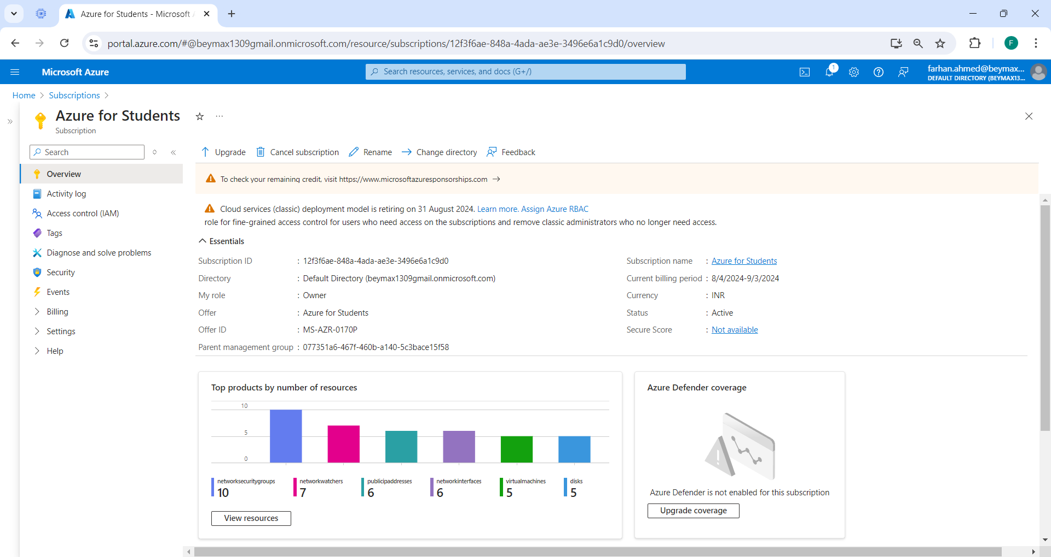Choose your subscription name.
* 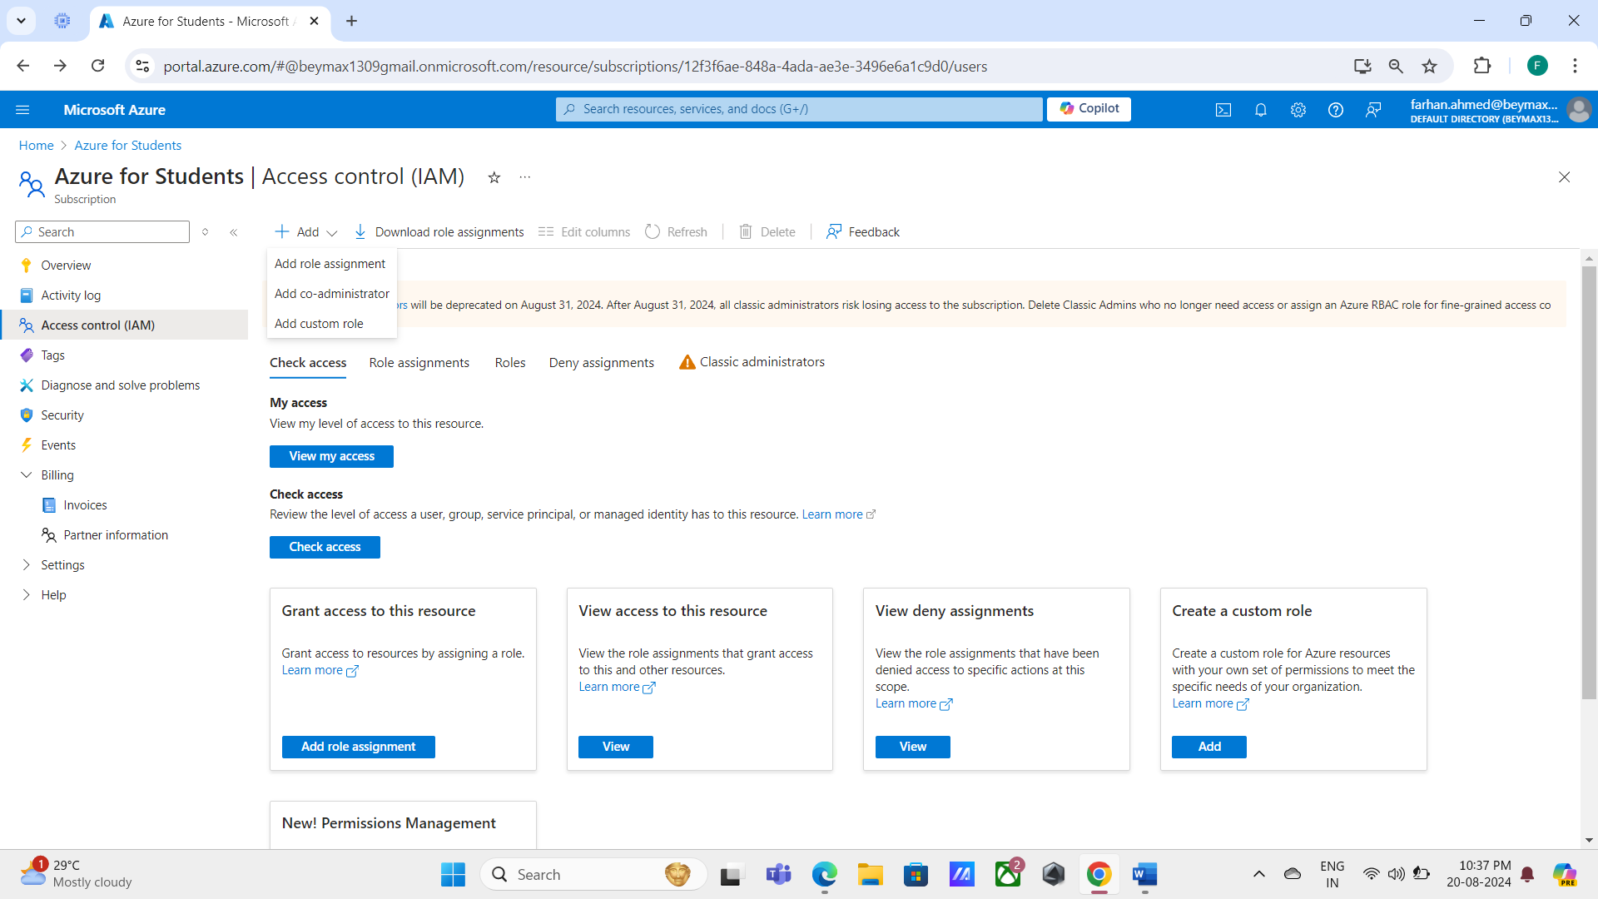Click on access control (IAM) now, and create a custom role for migration.
* Give all the required details and select the baseline permissions starting from JSON and add the JSON file.

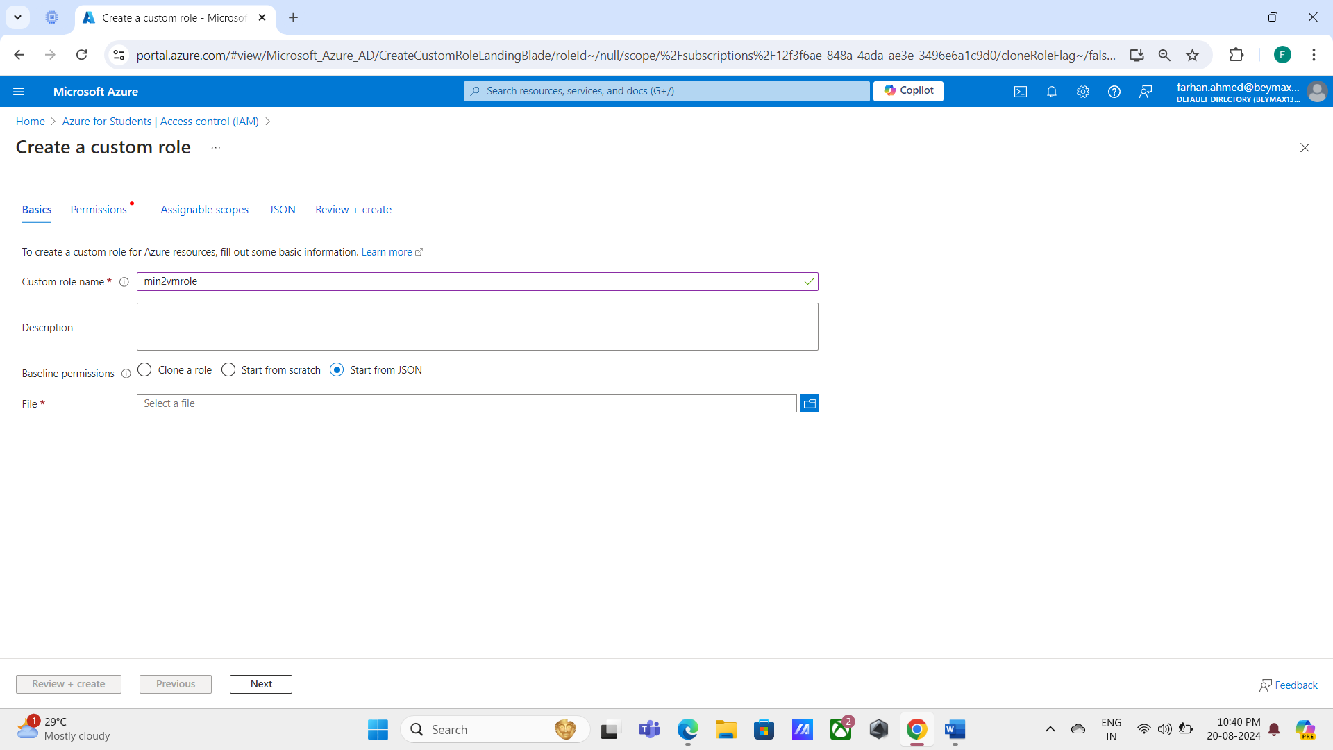

* For saving the JSON file-
  + Open the Google Cloud Portal, navigate to the Migration to Virtual Machines section, and click on [Create an Azure source](https://cloud.google.com/migrate/virtual-machines/docs/5.0/migrate/create-an-azure-source).
  + 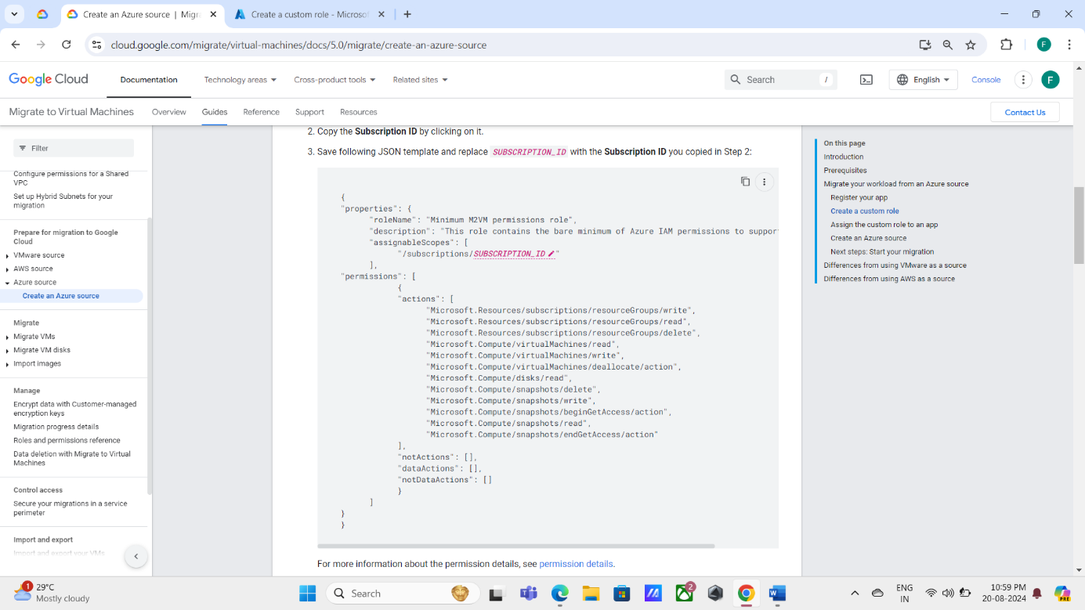Copy the JSON template and replace *SUBSCRIPTION_ID* with your Azure Subscription ID.

(Save the JSON template after entering your Azure subscription ID.)

* 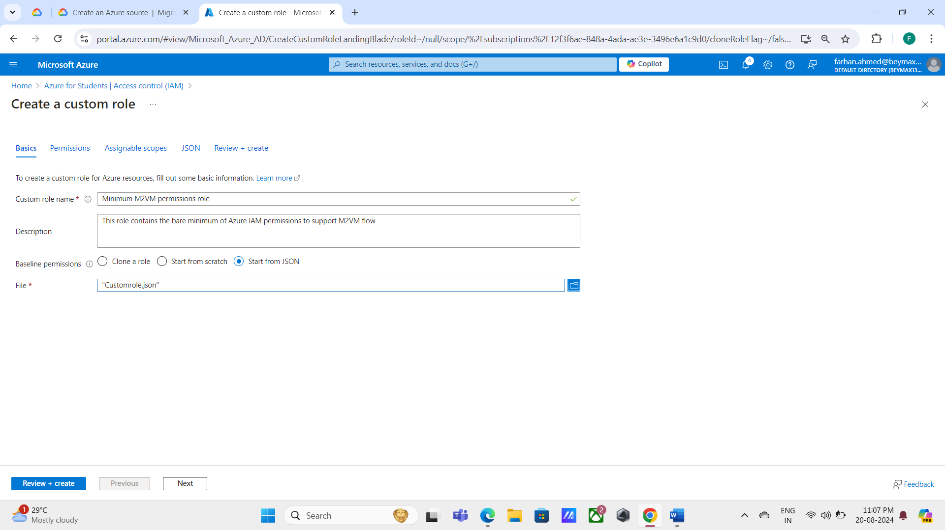Select the file.
* 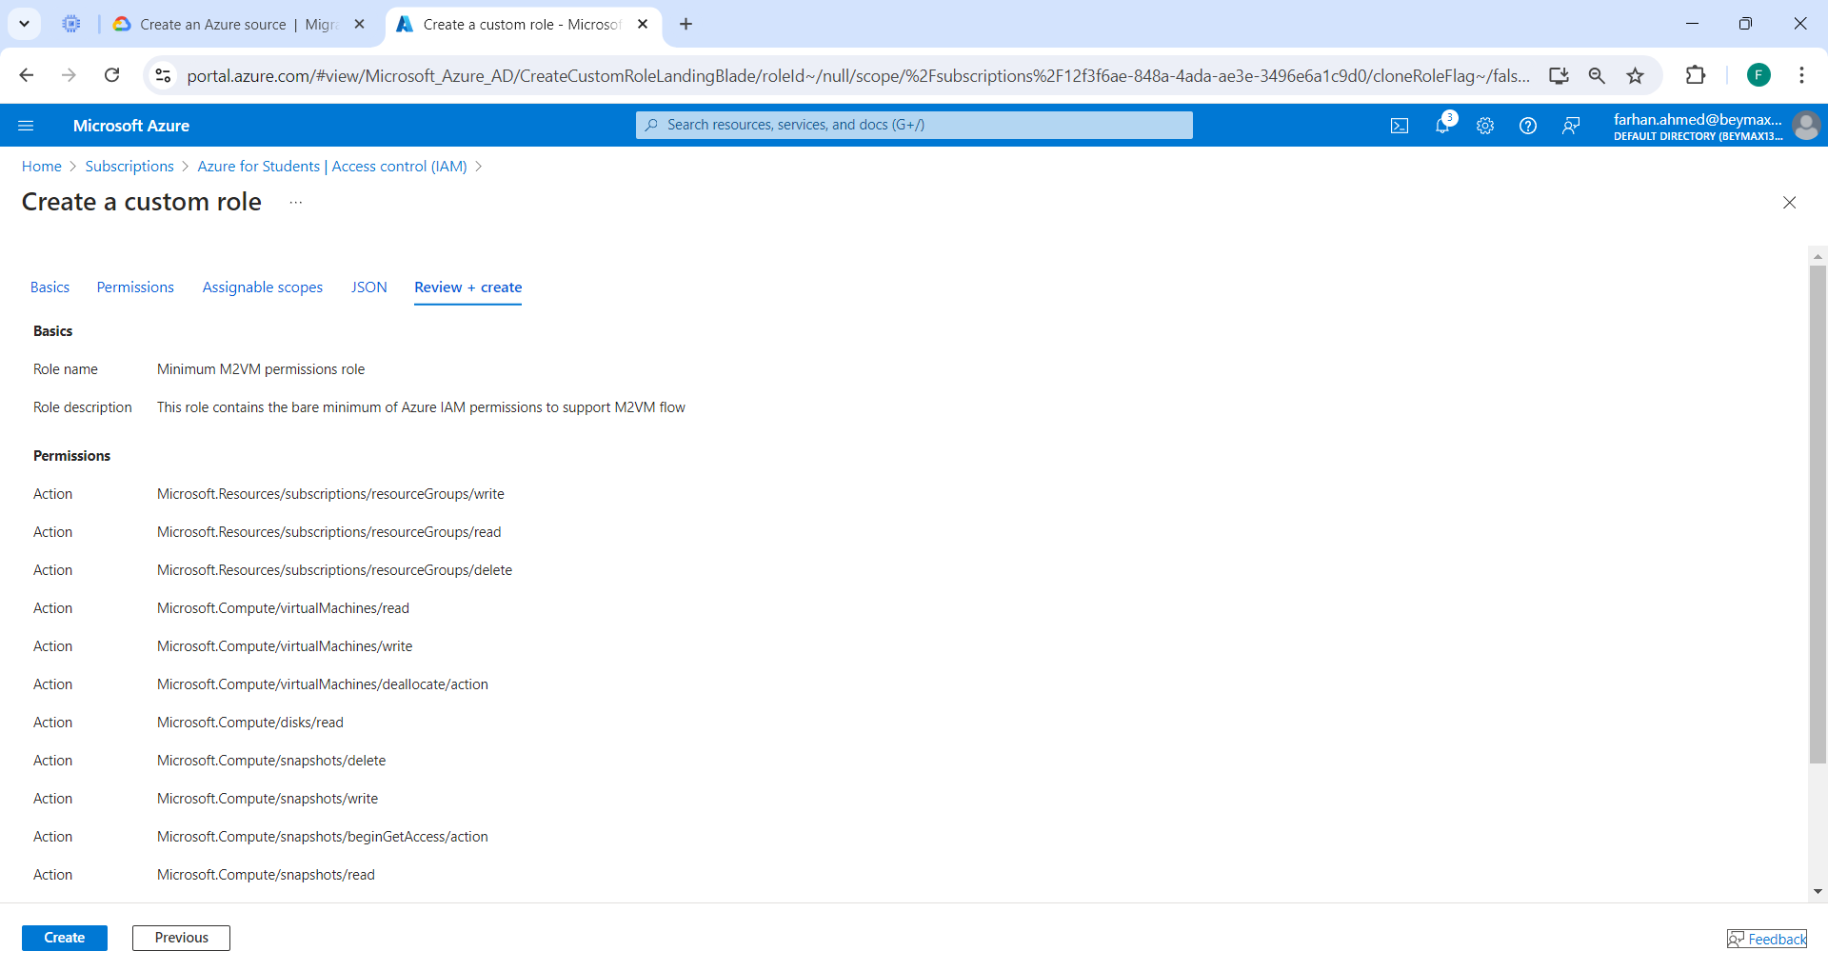Click on Create and the custom role will be added.
* 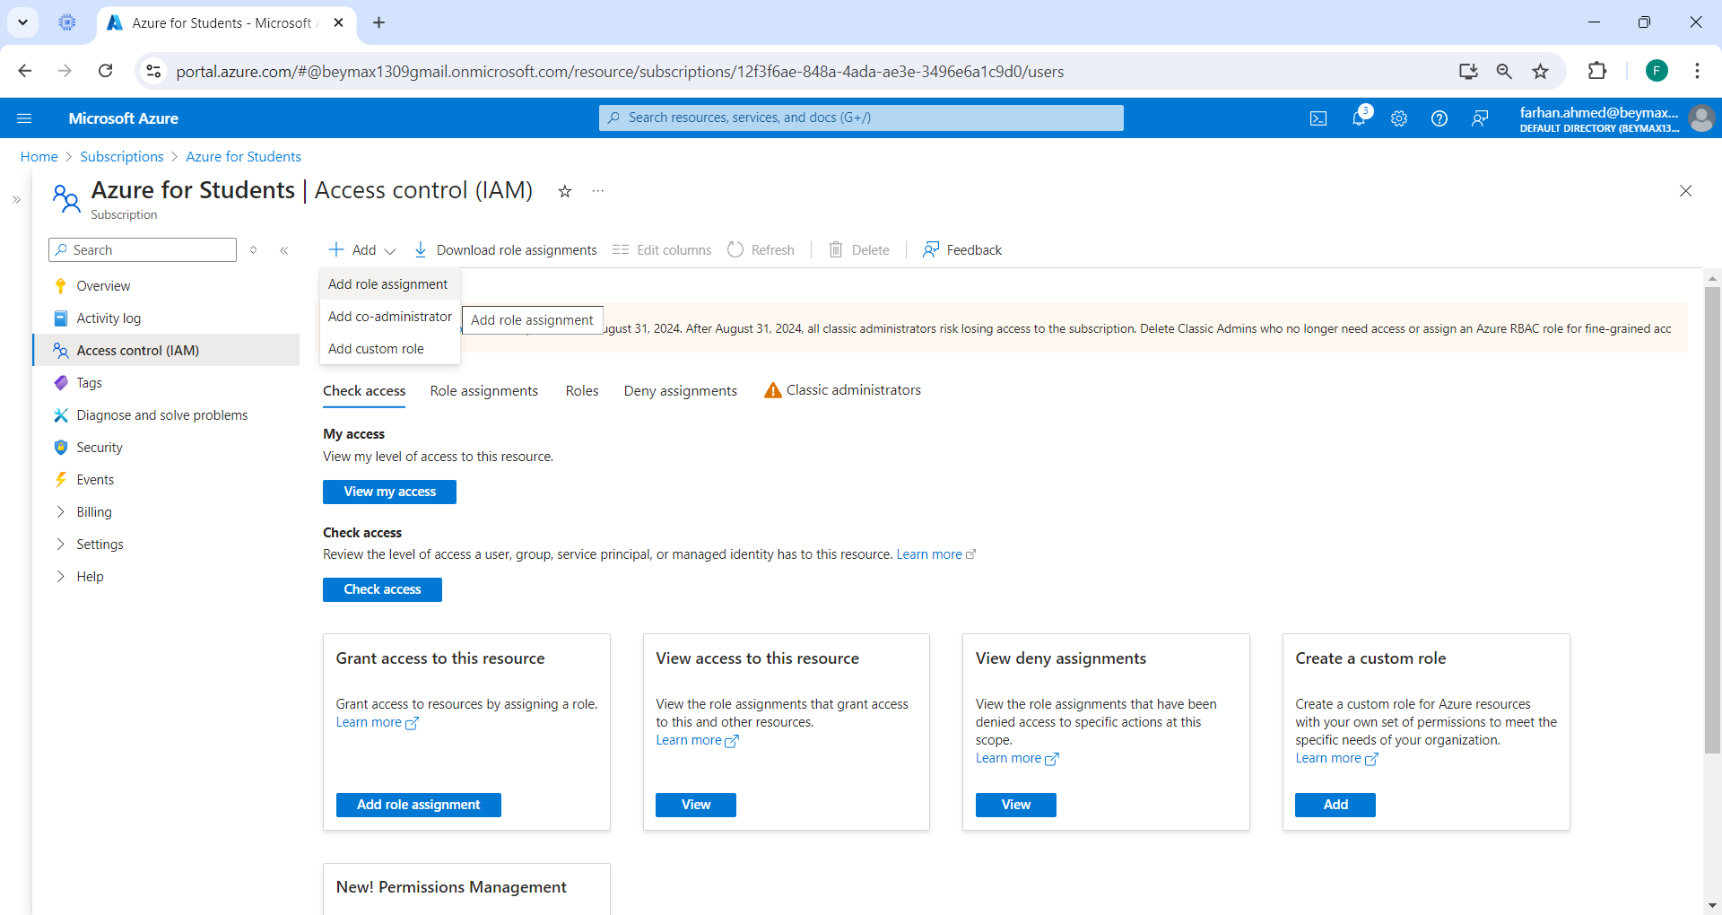We will grant access to that custom role.
* 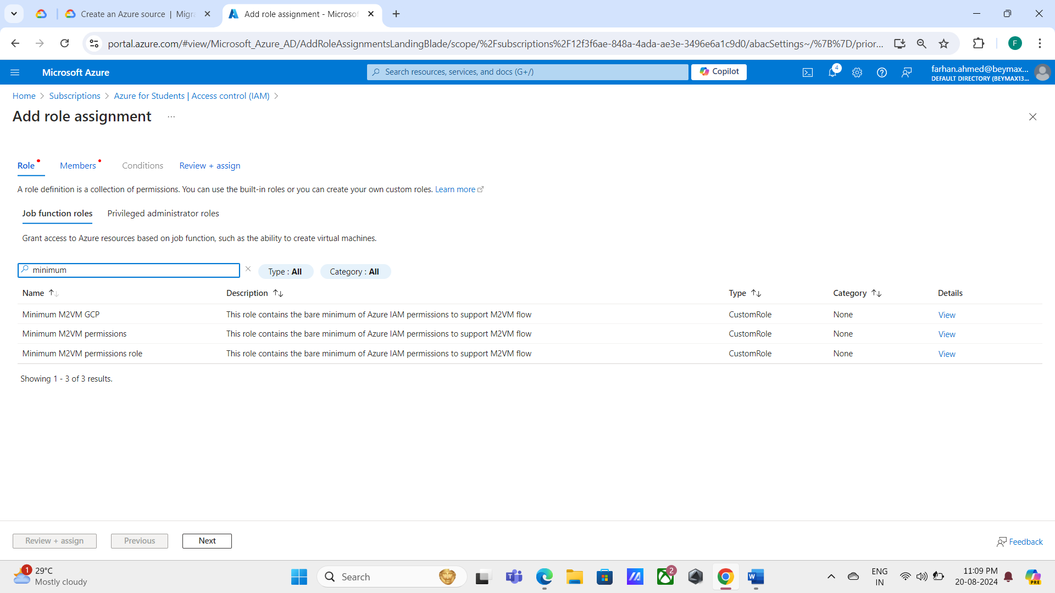Select the job function roles you created and click on next.
* 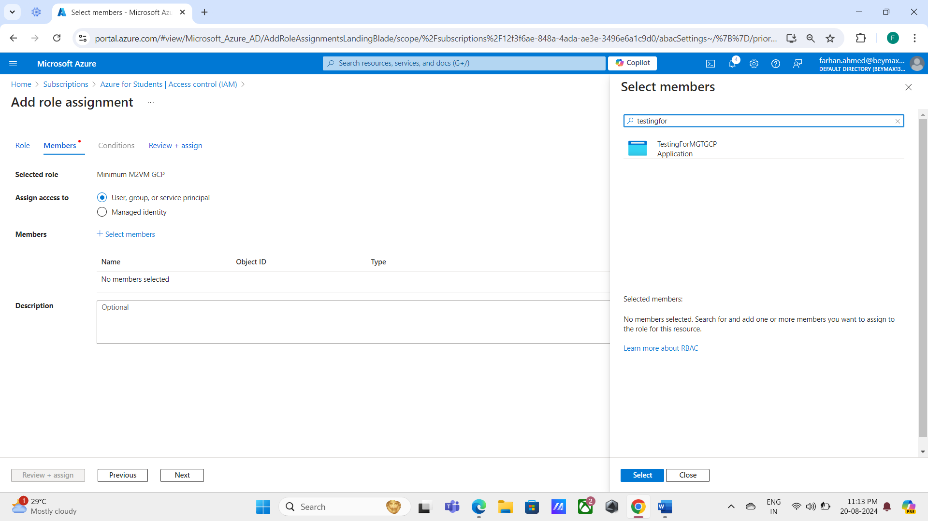Click "Select members" now and select the application that you registered and click on Select.
* Click on Review + assign.

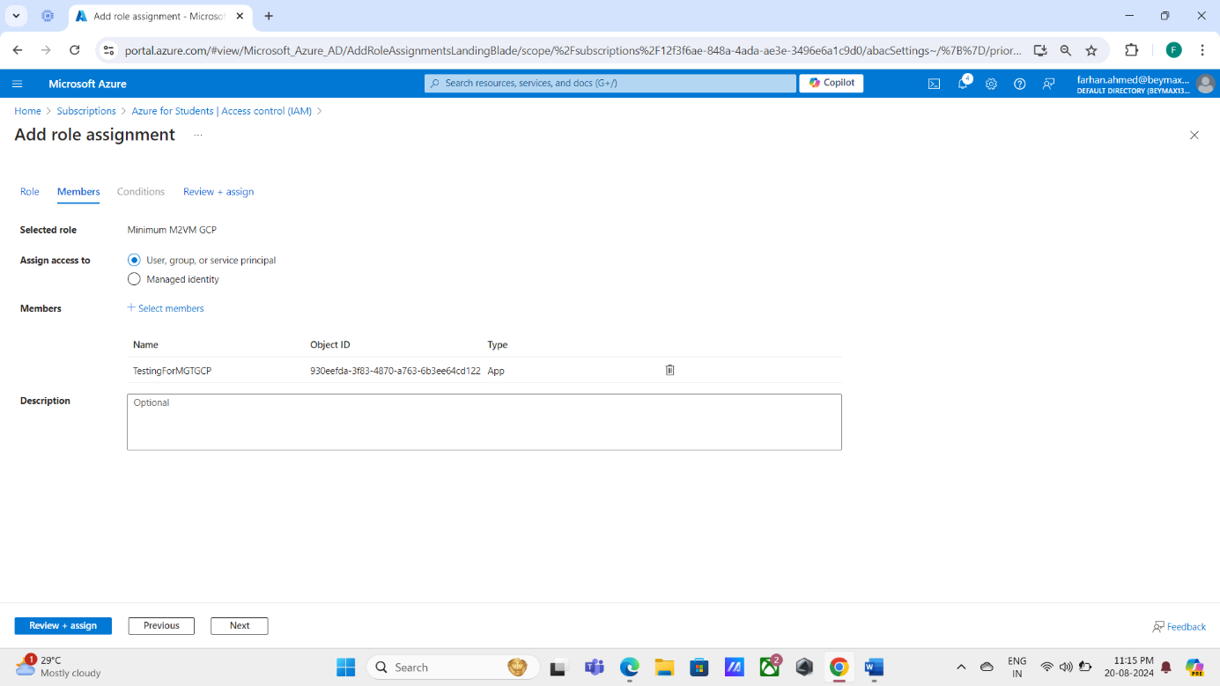

* **Now that we have finished our work on Azure for the application migration, we can move on to working with Google Cloud Console.**

1. ** WORKING ON GOOGLE CLOUD CONSOLE.**
   1. 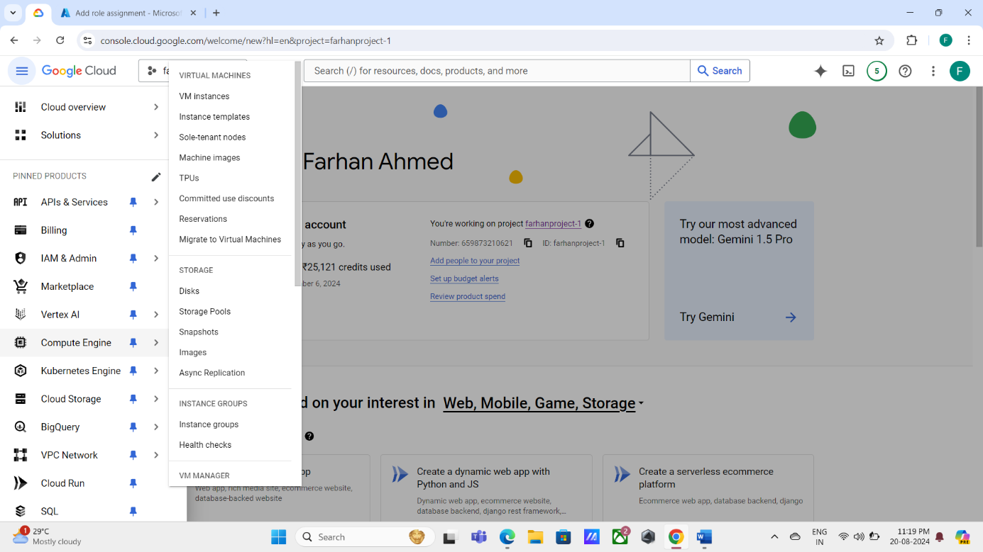Navigate to Virtual Machines on Compute Engine and select Migrate to Virtual Machines.

* 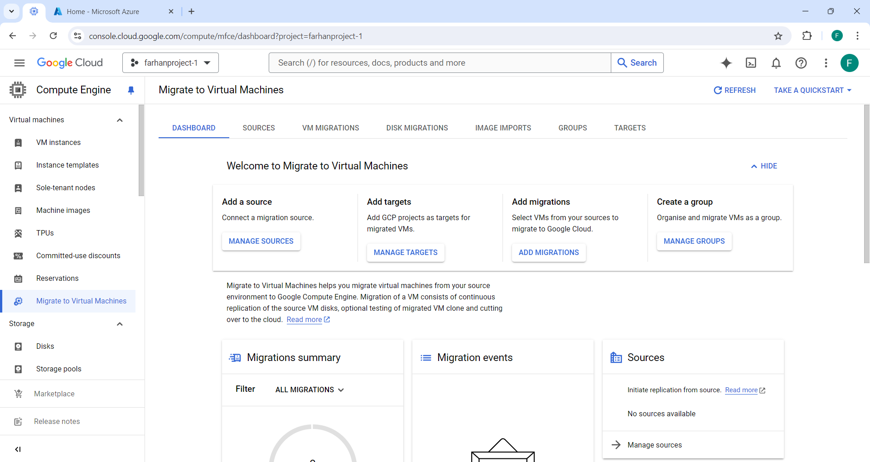Click on MANAGE SOURCES to add a source.
  1. 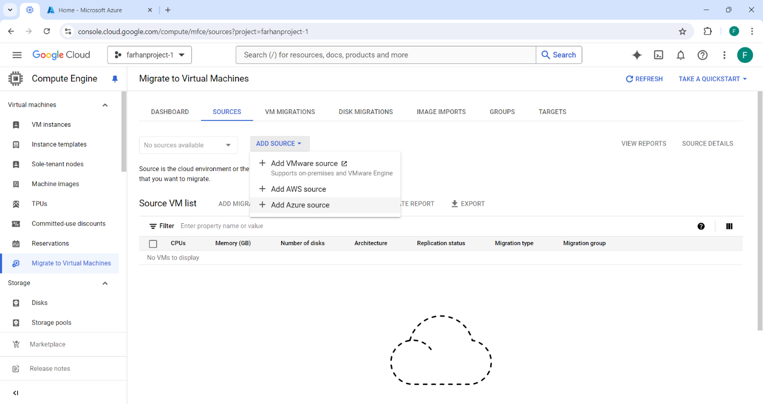Click on ADD SOURCE and select Add Azure source.
* 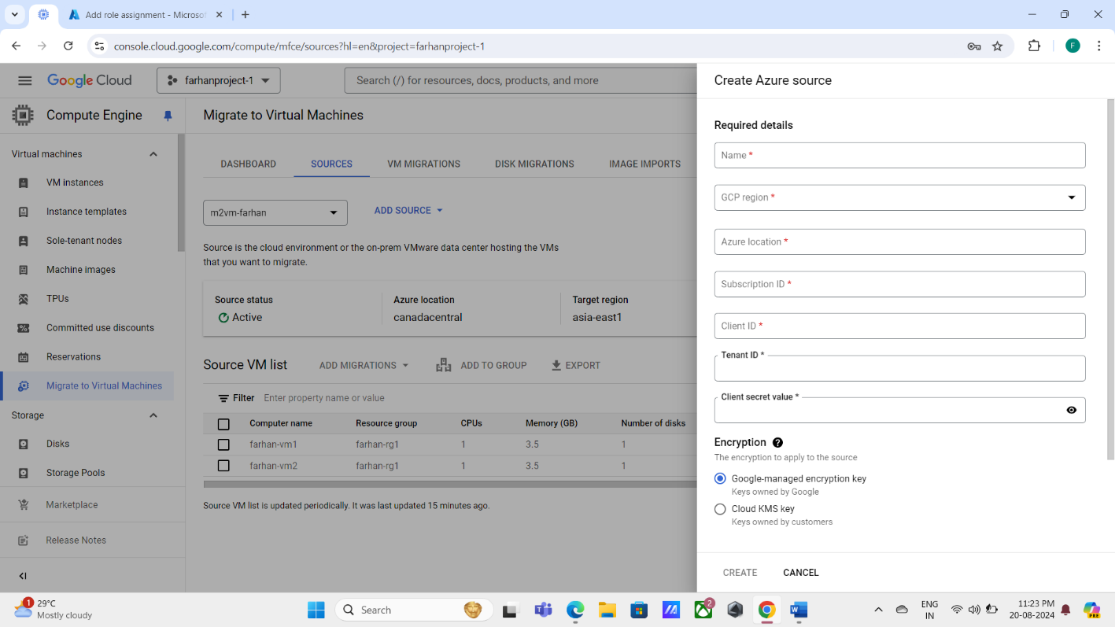Provide all the information that is required and that comes from the source cloud (Azure).
* 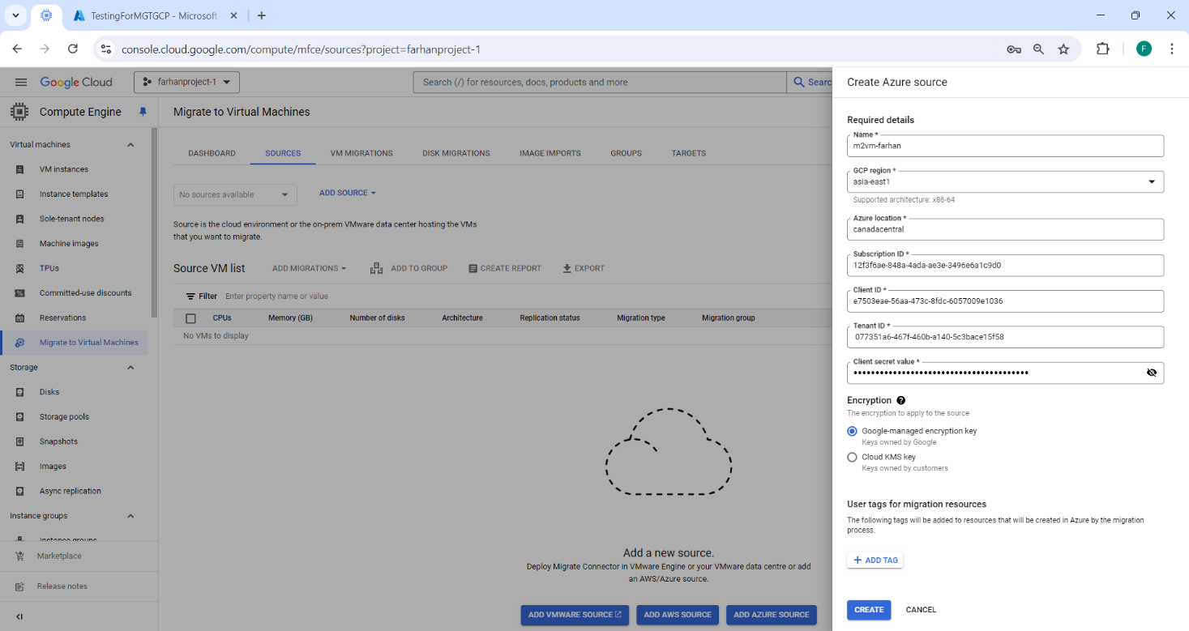Click on Create after providing all the details.
* (Azure location, Subscription ID, Client ID, Tenant ID and Client secret value details can be gathered from Azure.)
* 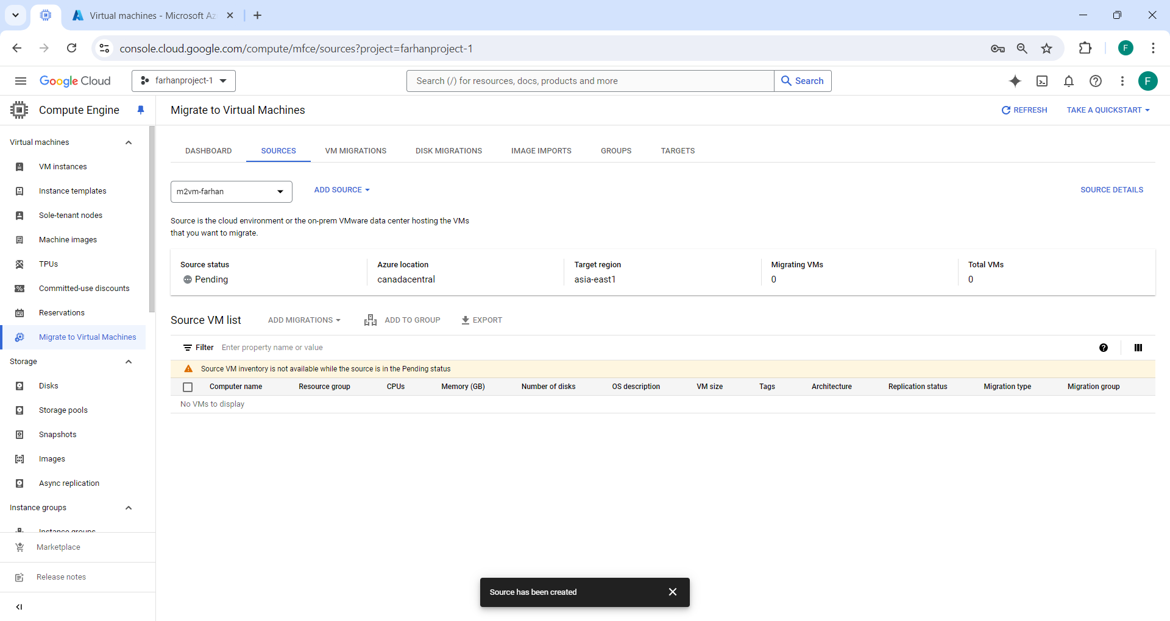In 10 to 15 minutes, the source virtual machines will be added, and their status will show activated.
  + - 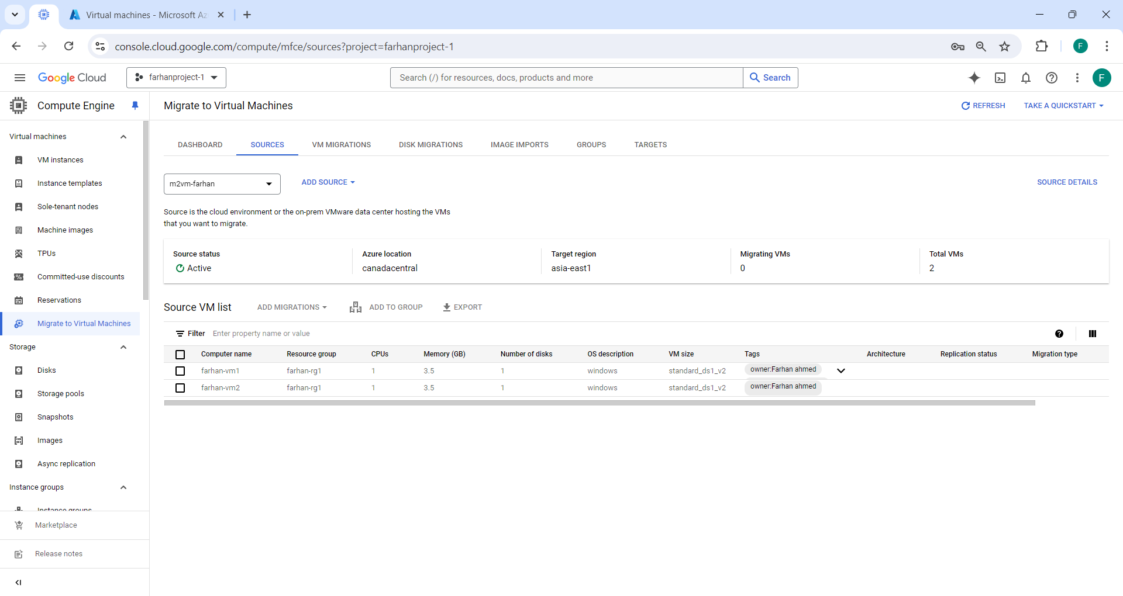The source status is active, and the migrated VMs are now accessible in the list of source VMs.
  1. Select the VM’s and click on ADD MIGRATIONS.
* Choose any one-
  + - * VM migration- used to migrate the entire VM.
      * 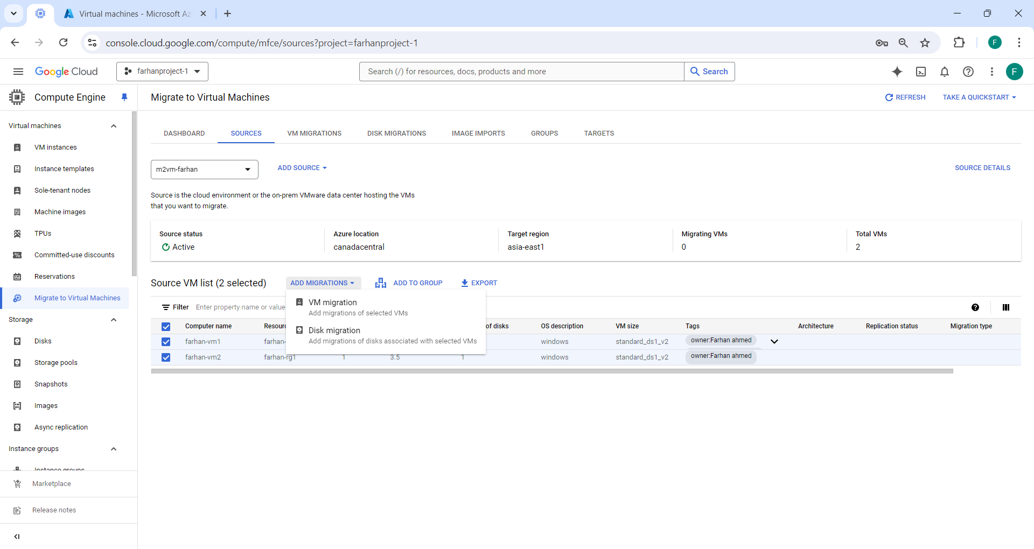 Disk migration-used to migrate the disks only.
      * The two chosen virtual machines are now accessible within the VM MIGRATIONS segment.

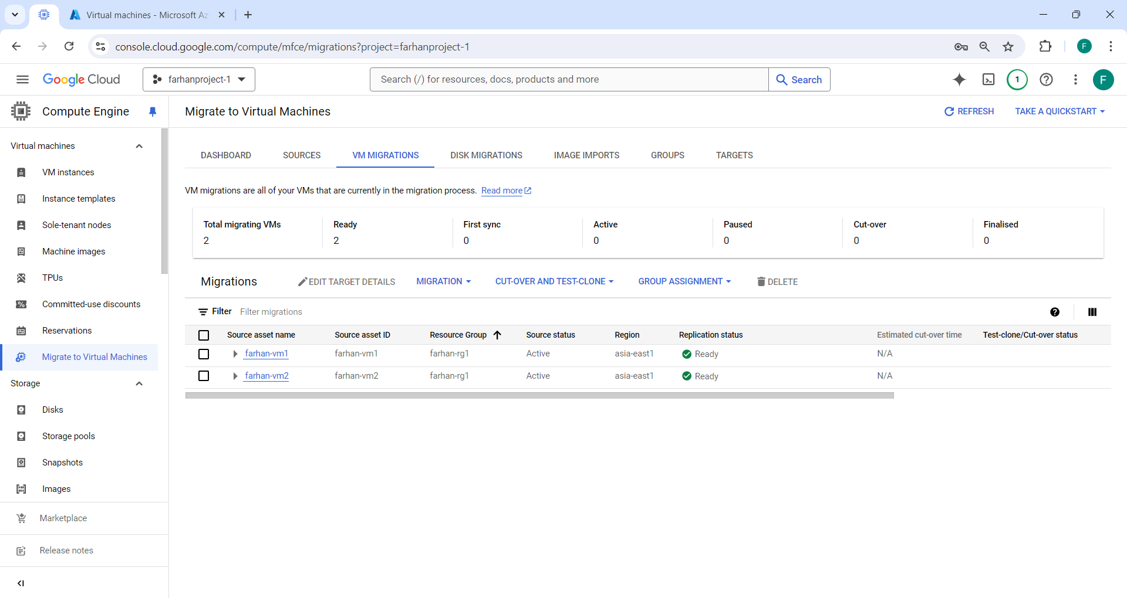

* To start the replication process after choosing the virtual machines, select MIGRATIONS and then click "Start replication."

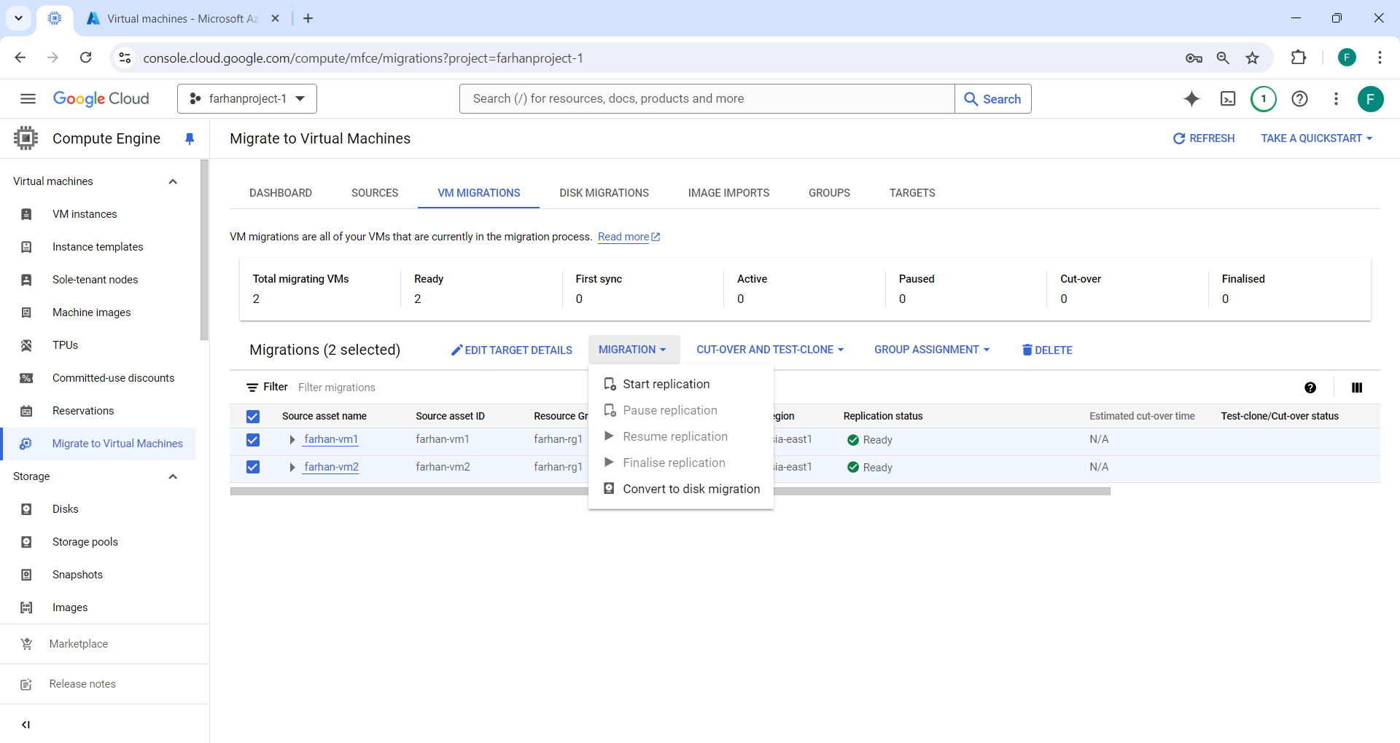

* 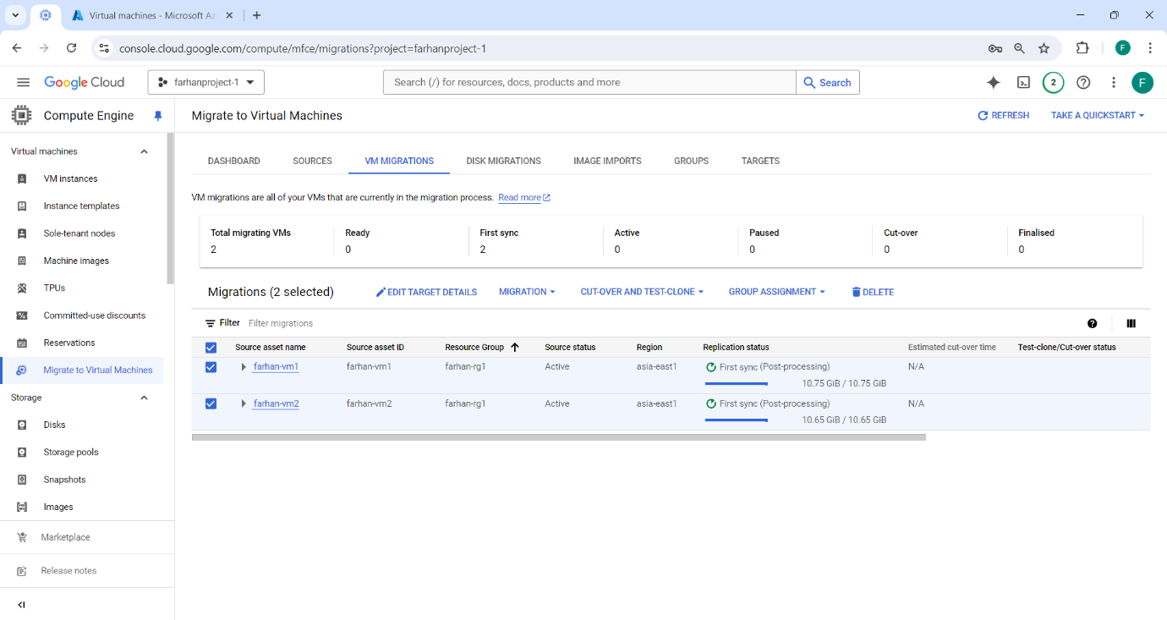Replication started.
  + - (Replication time for the VM will depend on the data that is available at the source VM’s)
  1. We will Select the VM’s and click on EDIT TARGET DETAILS so that we can perform TEST-CLONE or CUT-OVER.
     + - Select all the necessary Target details as it describes the environment and configuration of the Compute Engine instance created when running test-clone or cut-over.

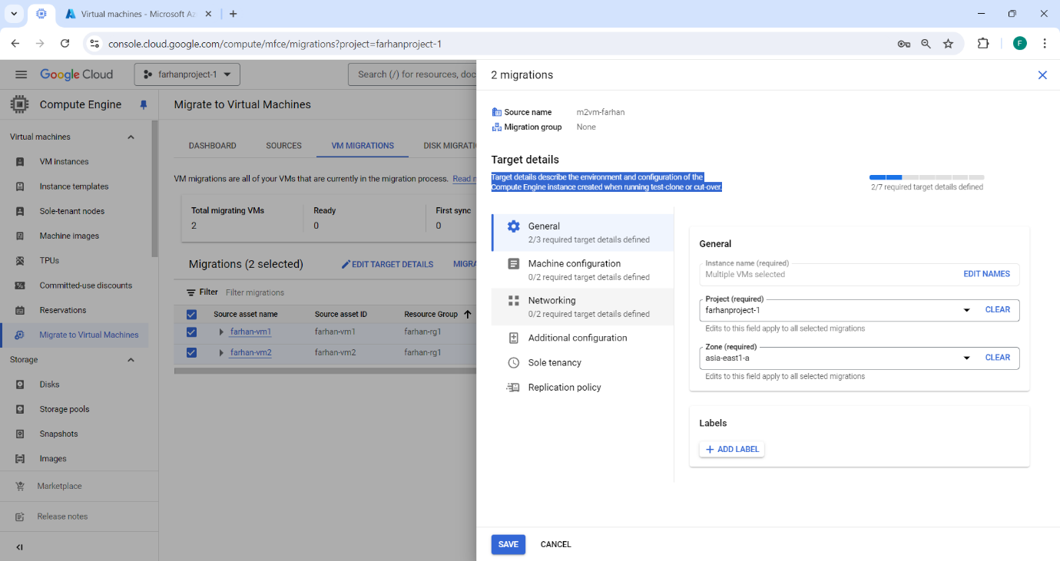



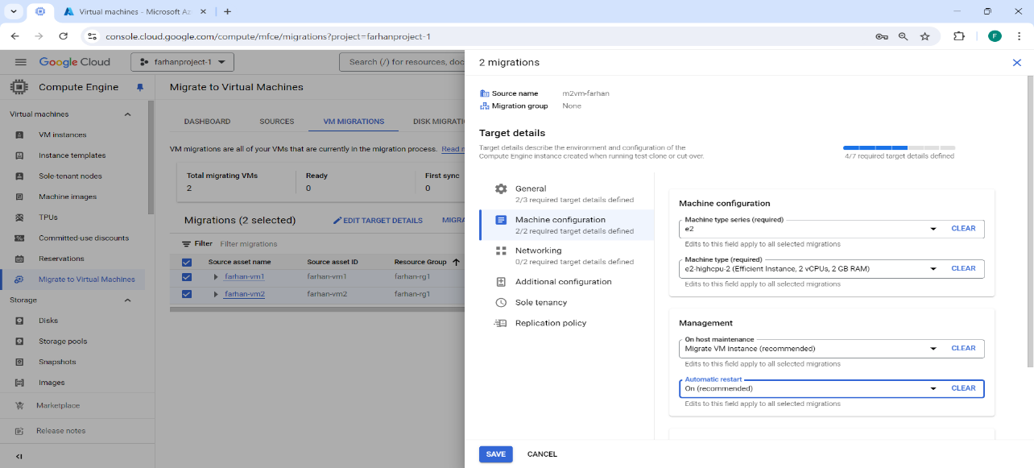

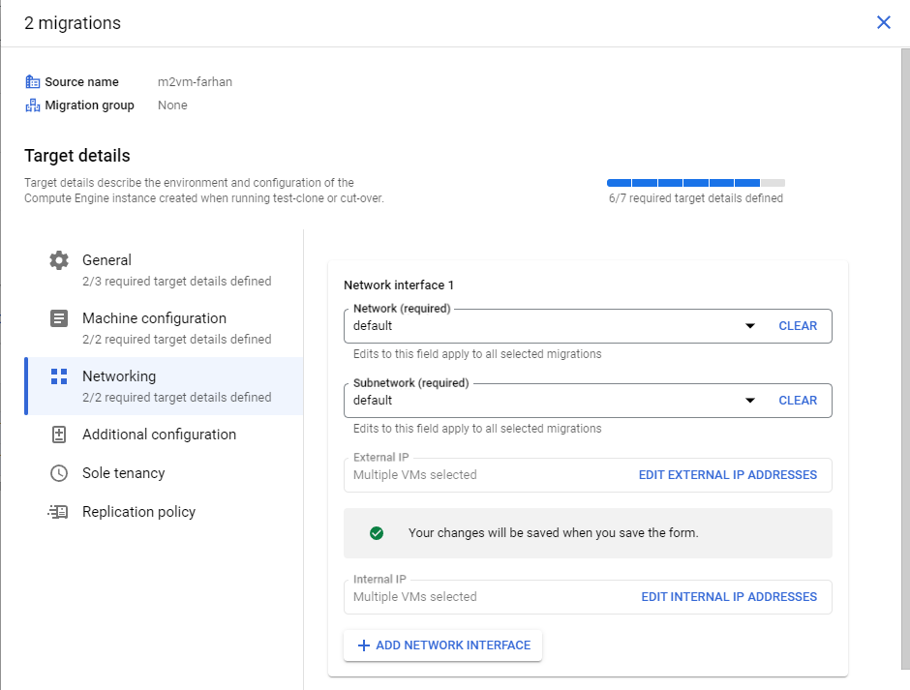



* 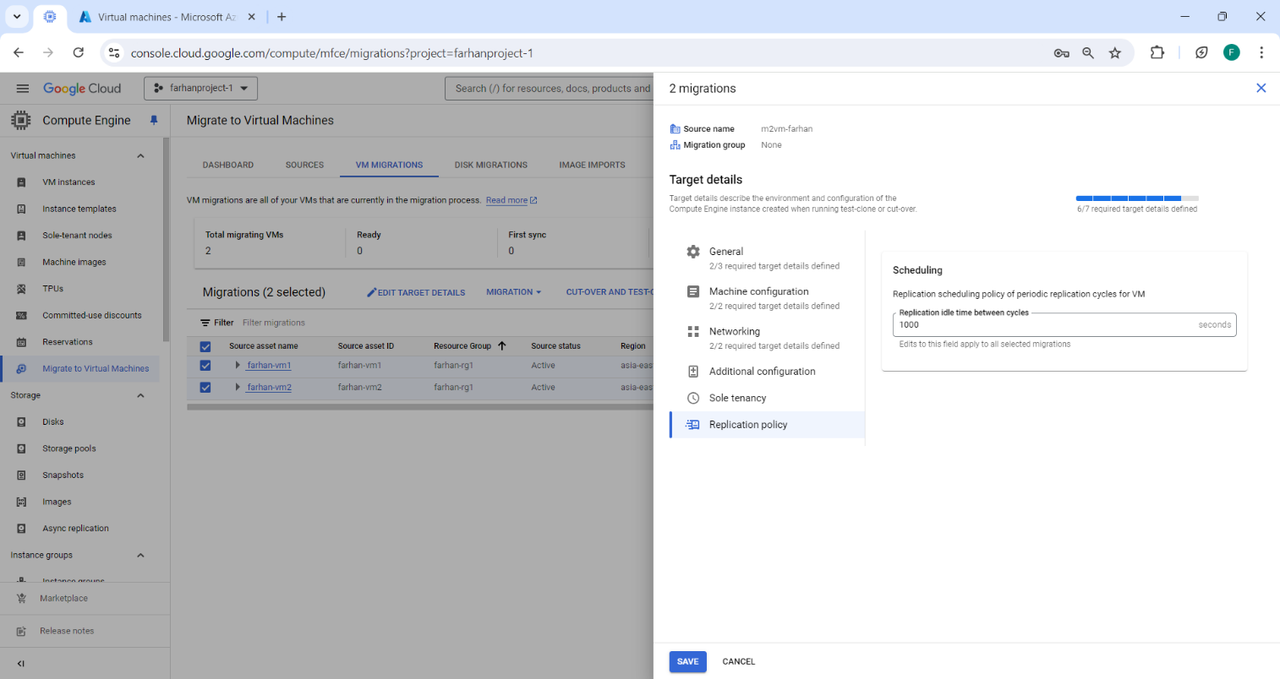Now click on save.
  1. Select the VM’s and click on TEST-CLONE or CUT- OVER to perform the failover.
* TEST CLONE- The VM from the source platform, then moves the clone to Compute Engine for testing.
* 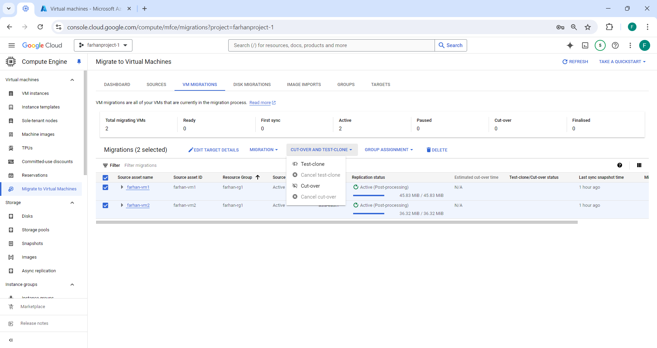CUT-OVER-This process includes stopping the source VM, completing a final replication, and creating the production Compute Engine instance from the source VM.
  + - 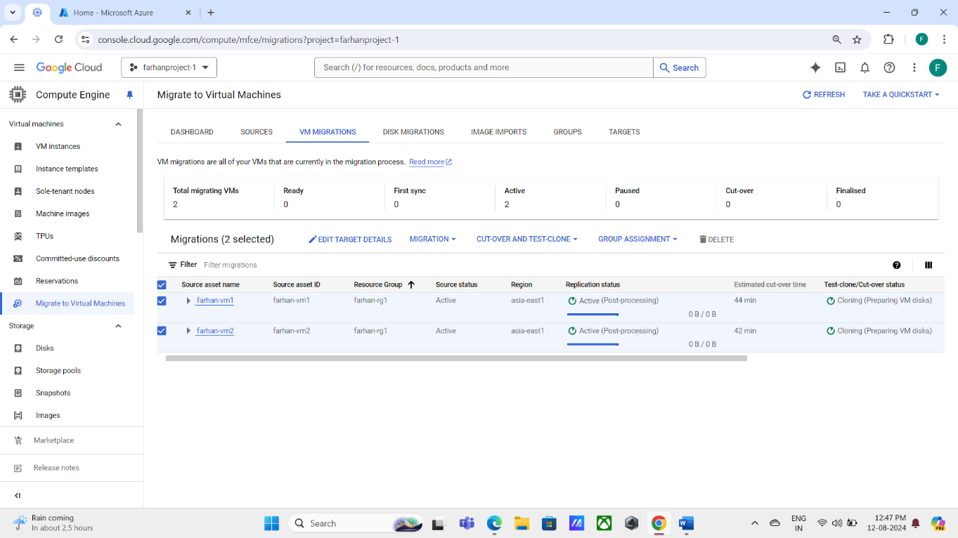TEST-CLONE has been started.
    - 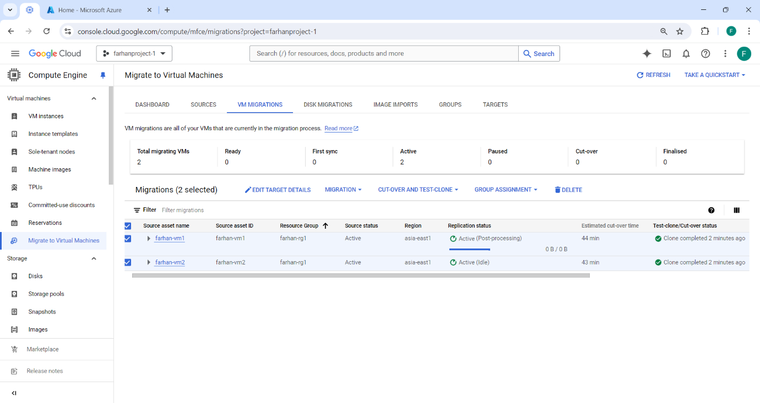TEST-CLONE is now completed.
  1. 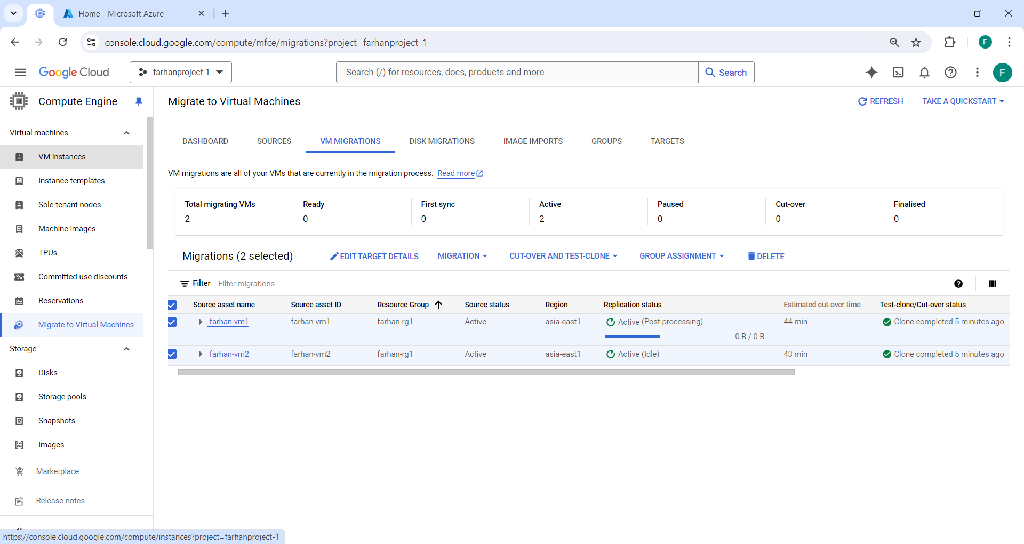Click on VM instances.
  + 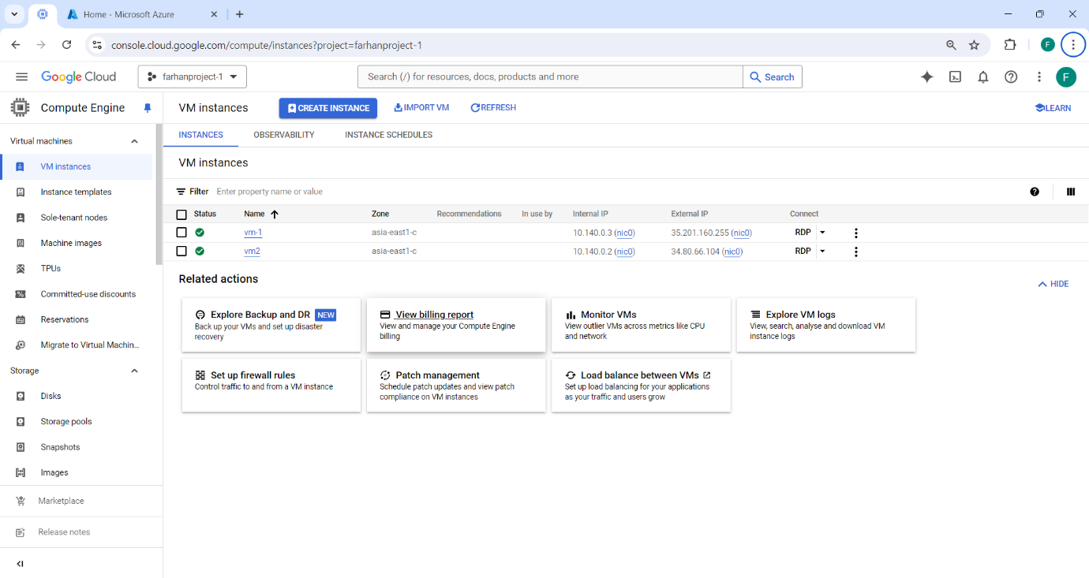Both of our virtual machines are now accessible within the virtual instances.
  1. Now that we have moved our machines from the source cloud, we will connect to them via Remote Desktop Connection (RDC) by copying their external IP address.
     + Click on Connect.

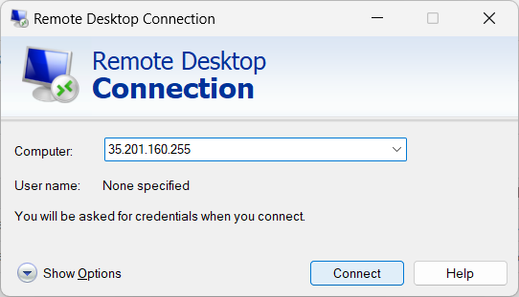

* + - Enter your credentials for login. (the same as your source clouds virtual machine).

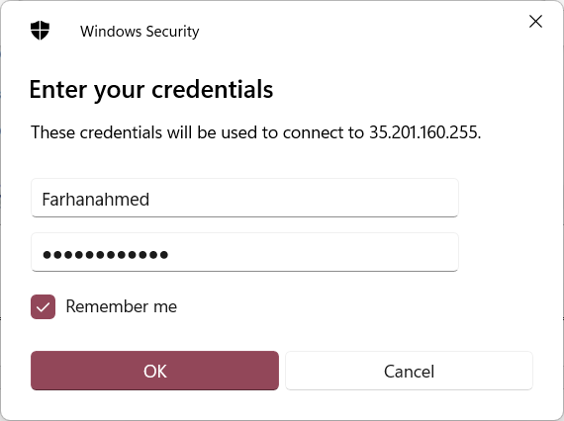

* + - 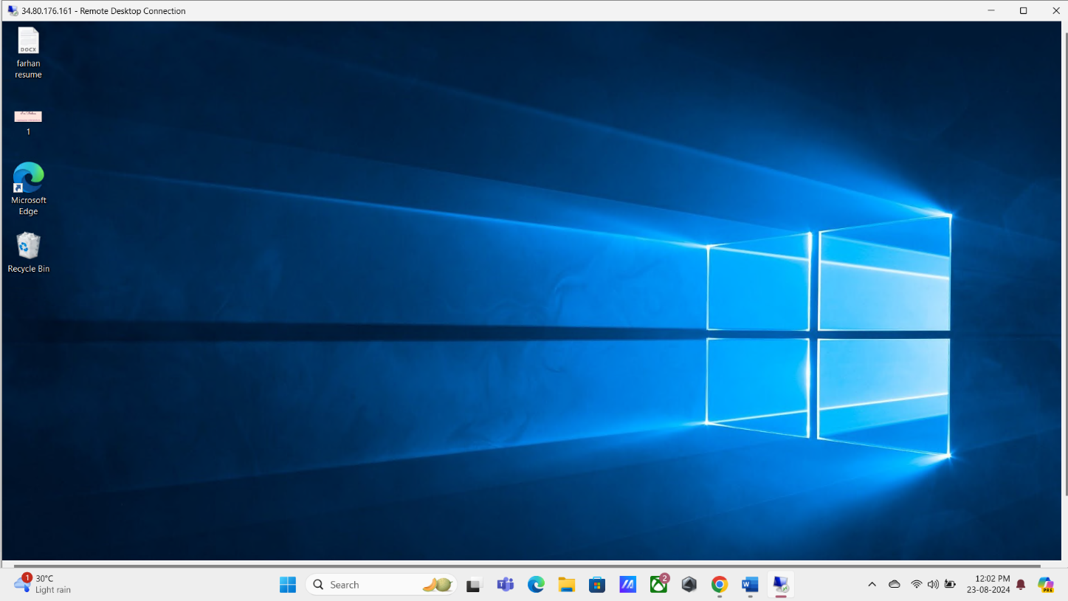Now that we are connected to the migrated VM-1, all of the data from the source virtual machine (VM) is accessible here and intact.
    - As all of our data was accessible in the migrated VM in GCP, we published a website in source VM to further confirm it. To access the published website, connect to the VM via Remote Desktop Connection (RDC) and type **local host** in any local browser.

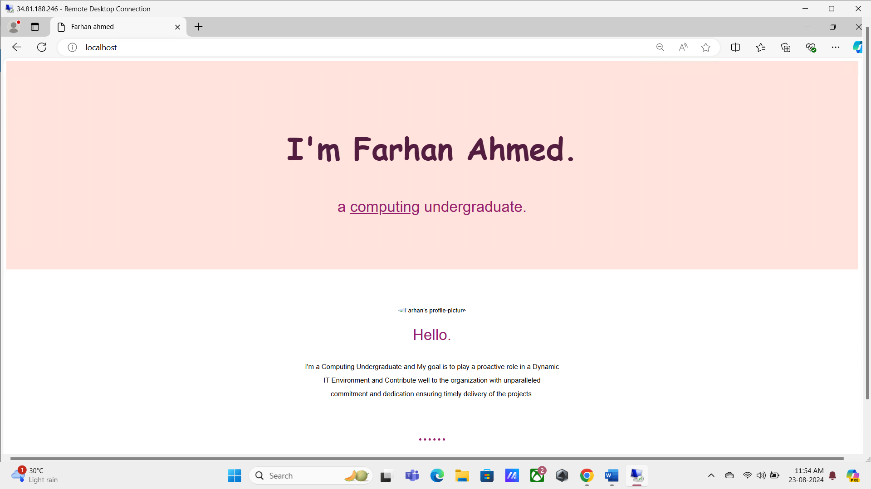

* **We can therefore conclude that the application's migration from Azure to Google Cloud Platform was successful.**

**CONCLUSION**

In conclusion, the successful migration of our application from Microsoft Azure to Google Cloud Platform (GCP) marks a significant milestone in our journey toward optimizing our cloud infrastructure. This transition has enabled us to leverage the advanced capabilities of GCP, including enhanced data analytics, cost efficiency, and cutting-edge AI tools. By addressing the limitations of our previous environment and aligning with our long-term strategic goals, we have not only improved the performance and scalability of our applications but also positioned our organization to better capitalize on future opportunities in the rapidly evolving digital landscape. The seamless migration process, with minimal disruption to operations, underscores the effectiveness of our planning and execution, paving the way for continued innovation and growth in our cloud strategy.